Unsupervised QPC - Dimensionality Reduction
Wstępne testy na trywialnych danych.

Algorytm
- Inicjalizacja prototypów w centach przedziałów utworzonych po zrzutowaniu na w
- Dla każdego kierunku uczenie powtarzane kilka razy - wynik z najlepszą wartością indeksu wygrywa
Parametry uczenia
uqpc_parameters =
K: 2
QPCMethod: 'uqpc2'
uqpc_initiations: 10
qpc_parameters =
beta: 0.1000
checkPeriod: 5
directions: 2
display: 'none'
eps: 1.0000e-03
function: 'gauss'
indGmax: []
initiations: 10
initWeights: []
killPeriod: 10
killRatio: 0.5000
lambda: 0.1000
learningRate: 0.1000
log: 'off'
logFileName: []
maxIterations: 1000
multistart: 'no'
OptConf: []
OptMethod: 'gd'
orthogonalizationMethod: 'projection'
ortoWeights: []
plot: 'none'
plr: 0.1000
prototypes: 2
QPCMethod: 'uqpc2'
save: 'none'
savedir: []
stopCriterium: 2

Gauss2
Data description:
Brak
Scatter plot:
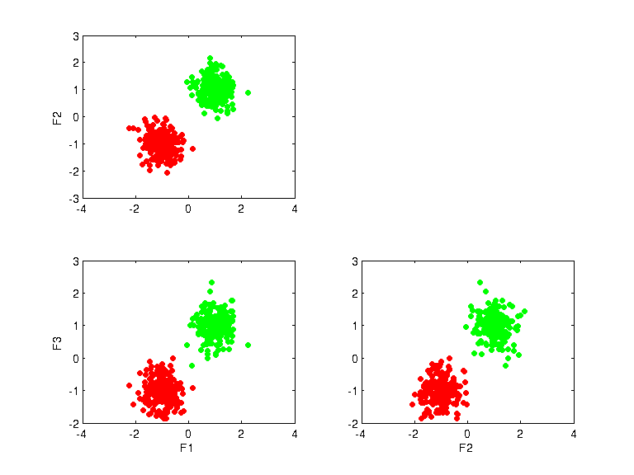
UQPC projections:
K=2
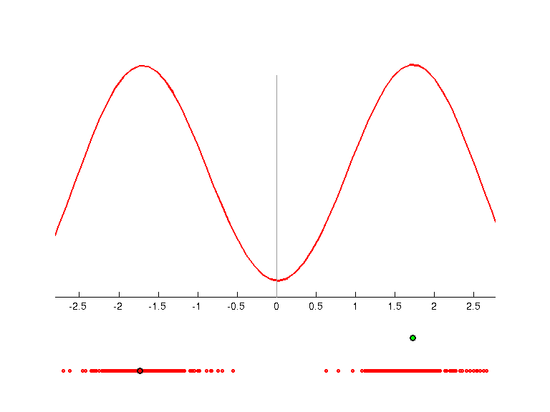 | 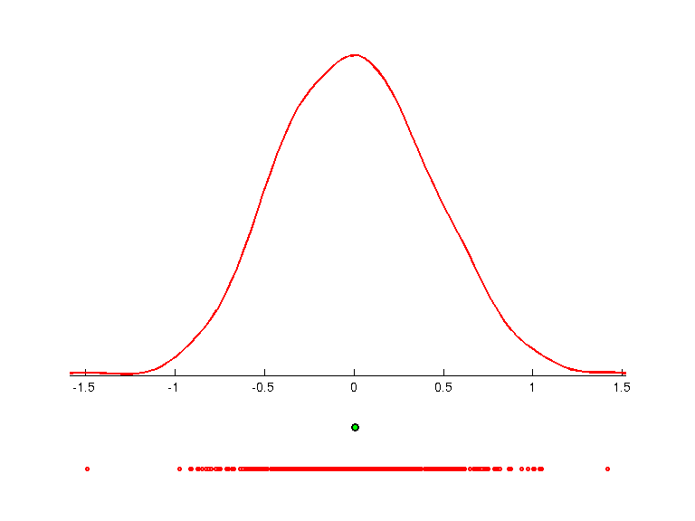 | 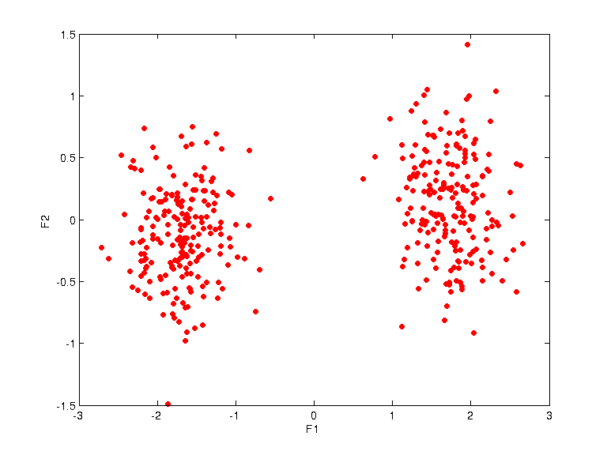
weights =
-0.5205 -0.4594 -0.7197
-0.8537 0.2647 0.4485
uqpc =
0.9358
0.4931
prototypes =
-1.7293 -46.0324 1.0000
1.7227 0.0056 2.0000
K=5
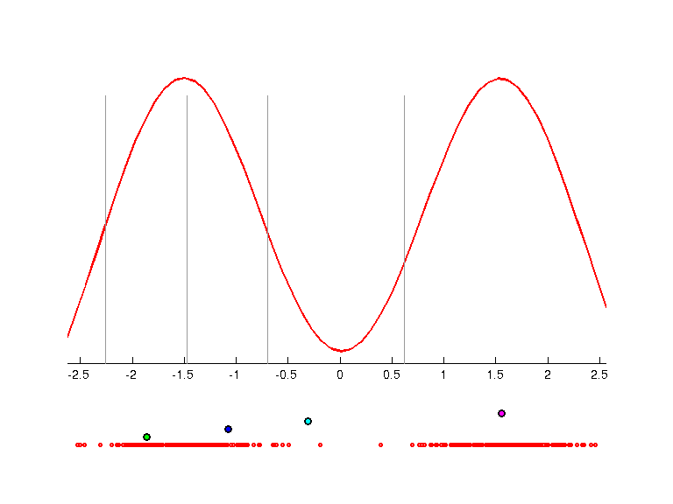 | 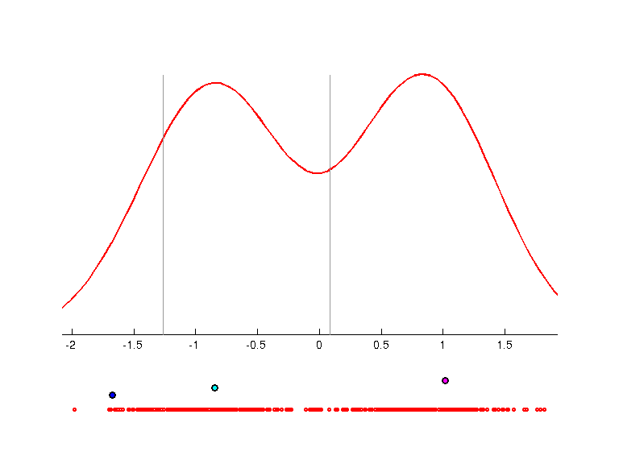 | 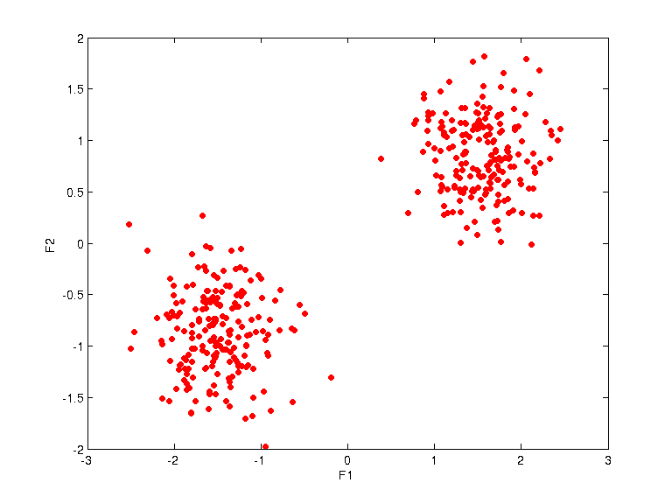
weights =
-0.3633 -0.2516 -0.8970
-0.4426 -0.8007 0.4038
uqpc =
0.7538
0.4436
prototypes =
-2.6504 -3.1922 1.0000
-1.8646 -3.1757 2.0000
-1.0769 -1.6754 3.0000
-0.3106 -0.8493 4.0000
1.5539 1.0189 5.0000

Gauss3a
Data description:
Brak
Scatter plot:
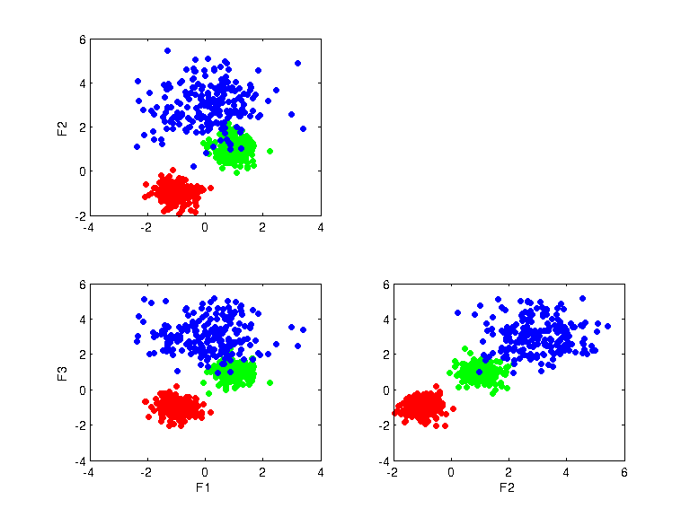
UQPC projections:
K=2
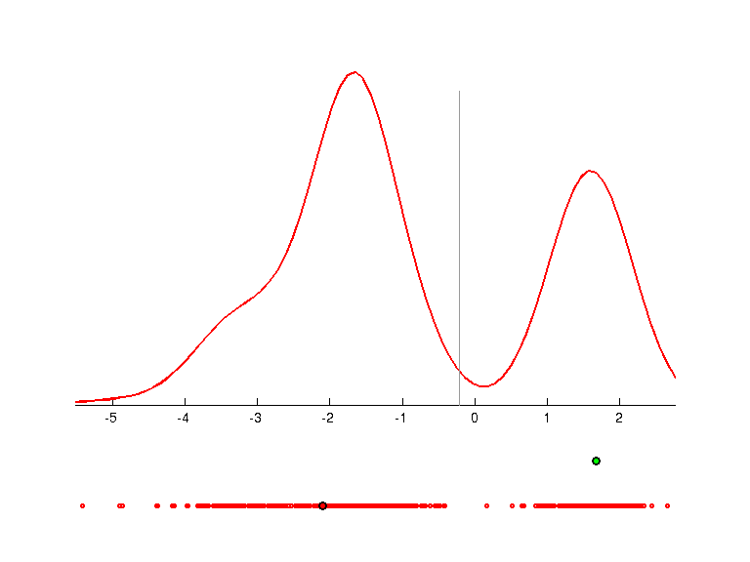 | 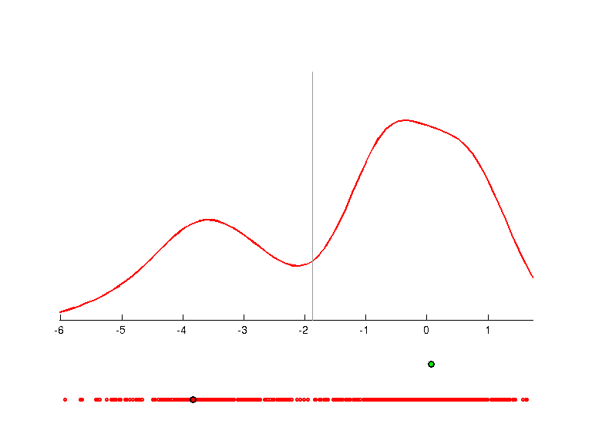 | 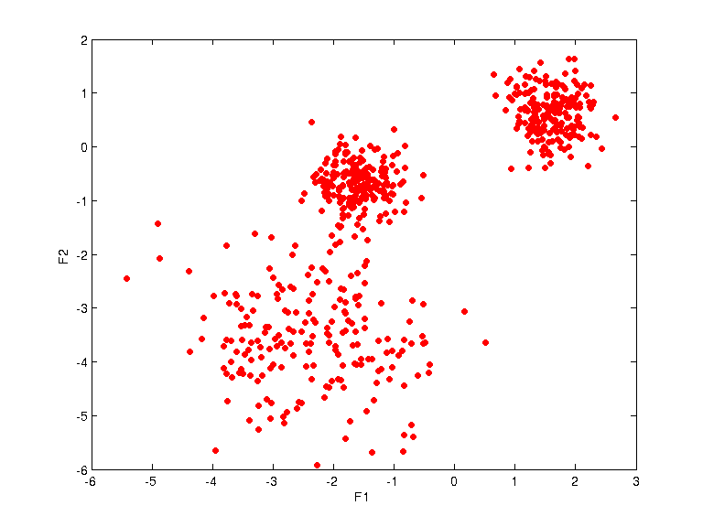
weights =
-0.8444 -0.3512 -0.4046
0.5354 -0.5231 -0.6631
uqpc =
0.8608
0.7956
prototypes =
-2.0960 -3.8309 1.0000
1.6772 0.0761 2.0000
K=3
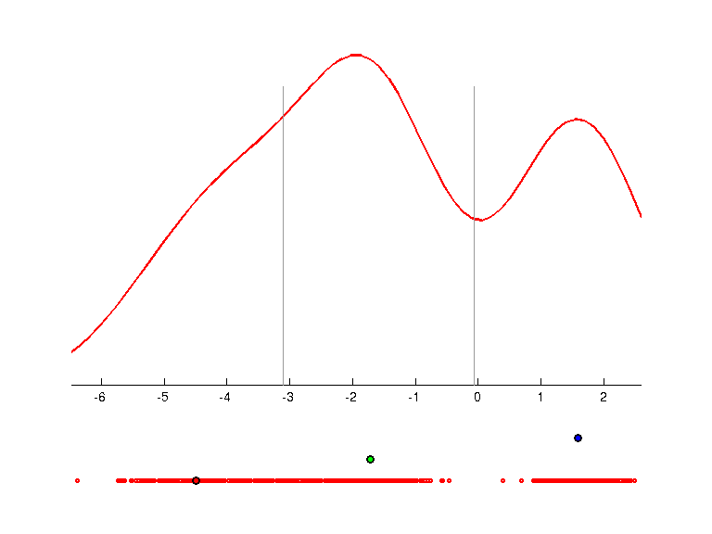 | 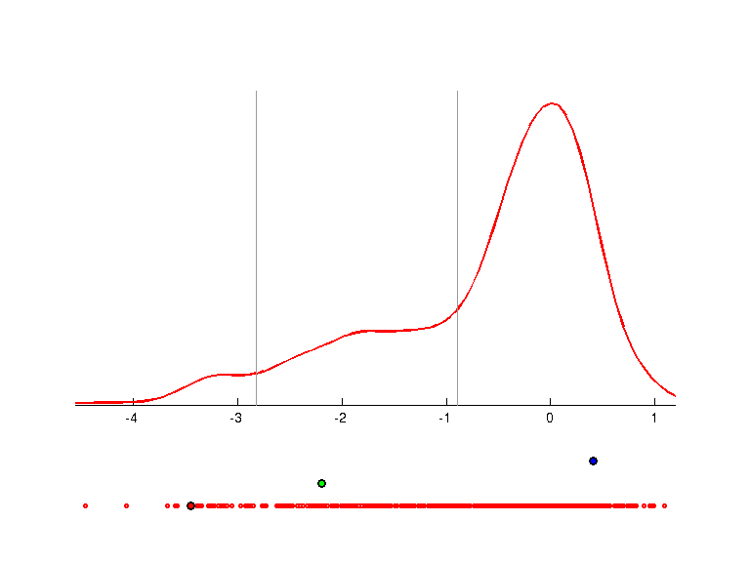 | 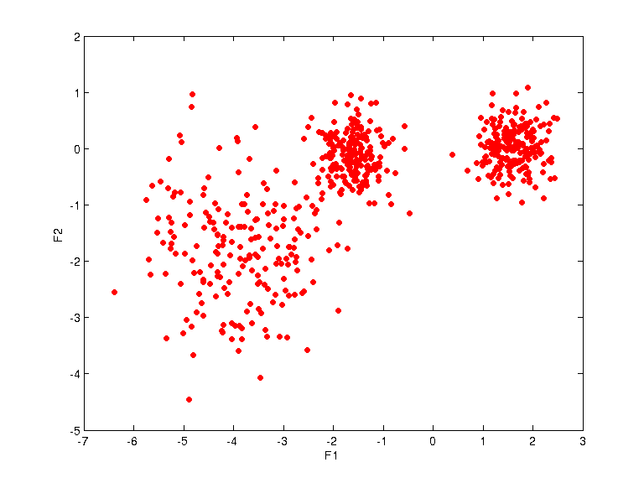
weights =
-0.3469 -0.4298 -0.8336
0.5608 -0.8075 0.1830
uqpc =
0.8405
0.7053
prototypes =
-4.4951 -3.4459 1.0000
-1.7234 -2.1913 2.0000
1.5922 0.4108 3.0000
K=4
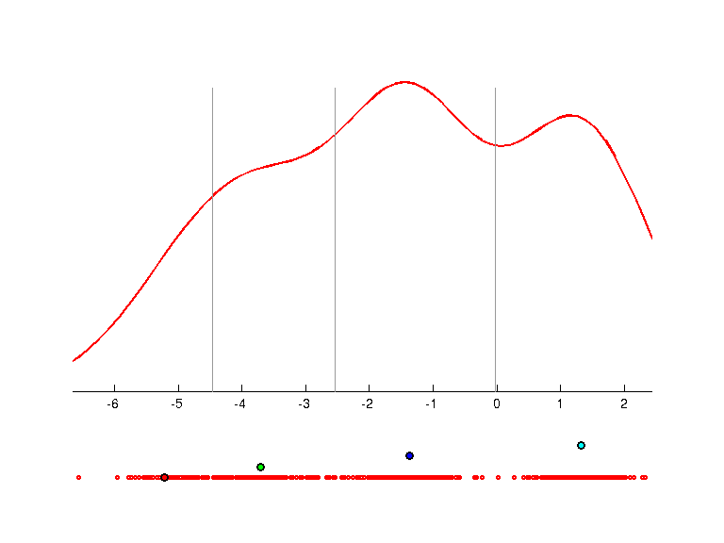 | 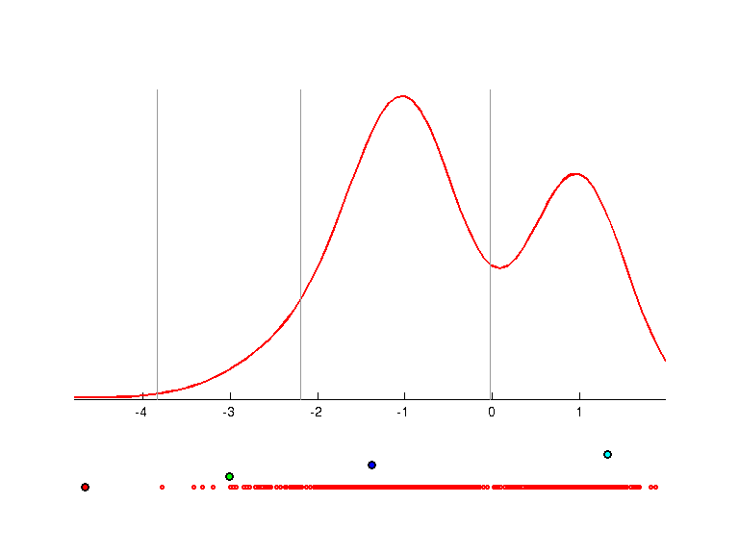 | 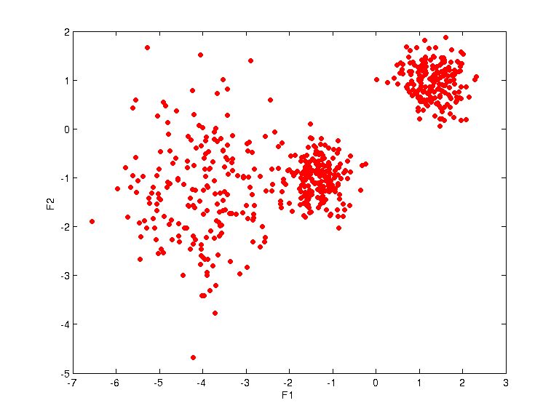
weights =
-0.0146 -0.3934 -0.9193
-0.5575 -0.7600 0.3341
uqpc =
0.8528
0.7751
prototypes =
-5.2141 -4.6549 1.0000
-3.7137 -3.0096 2.0000
-1.3728 -1.3748 3.0000
1.3218 1.3174 4.0000

Gauss3b
Data description:
Brak
Scatter plot:
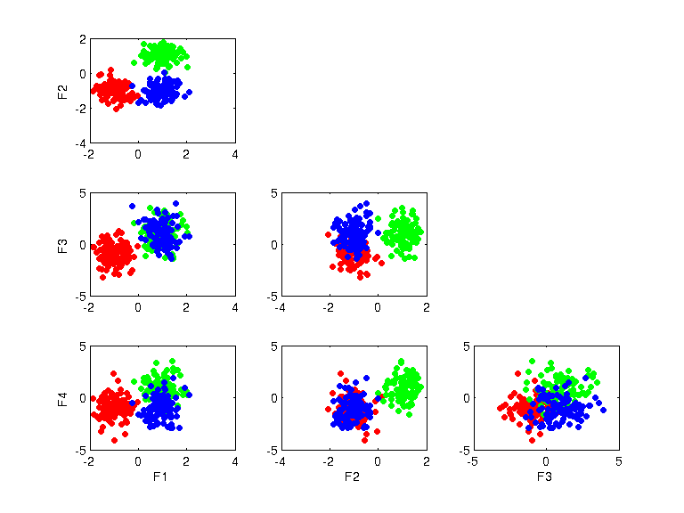
UQPC projections:
K=2
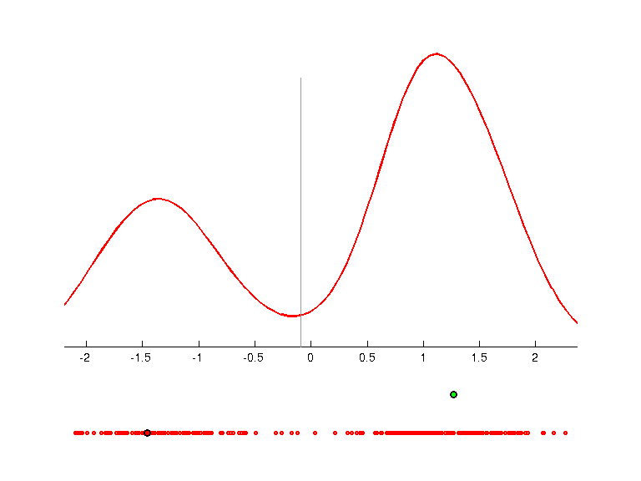 | 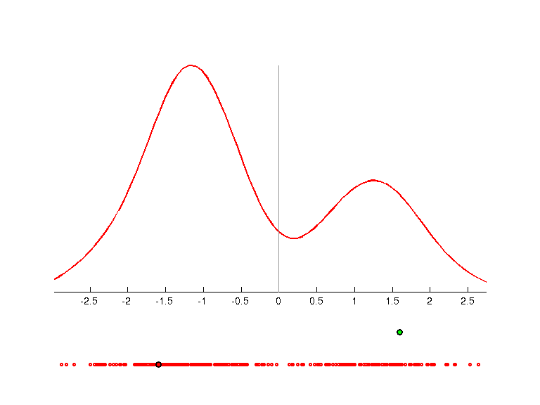 | 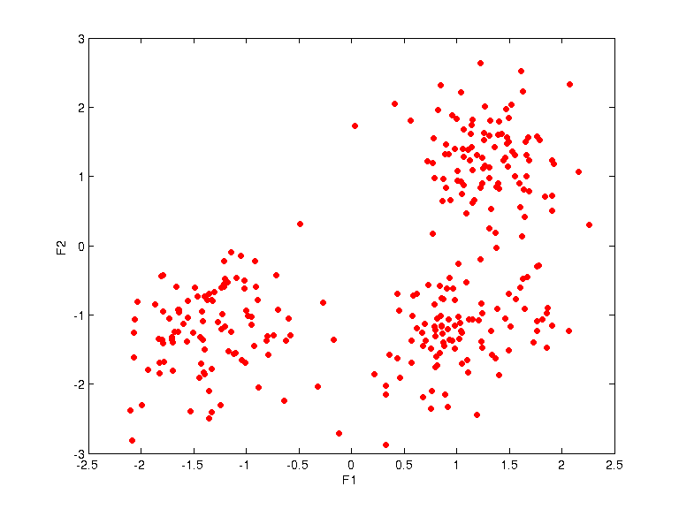
weights =
-0.1179 -0.9771 -0.0440 -0.1713
-0.8924 0.1510 -0.3998 -0.1450
uqpc =
0.8605
0.7629
prototypes =
-1.4600 -1.5977 1.0000
1.2719 1.5919 2.0000
K=3
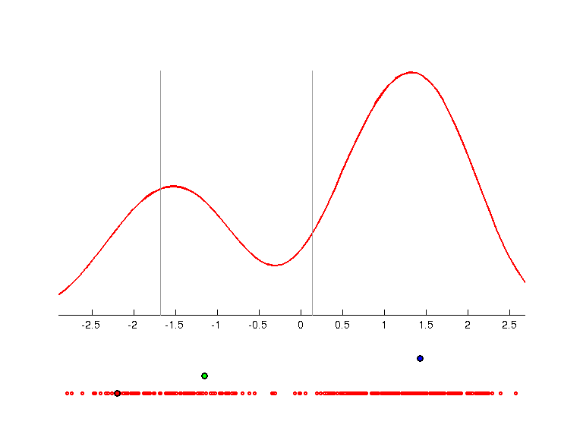 | 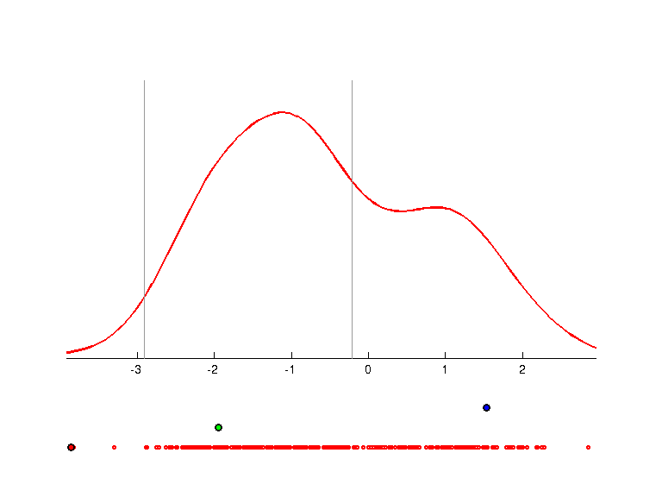 | 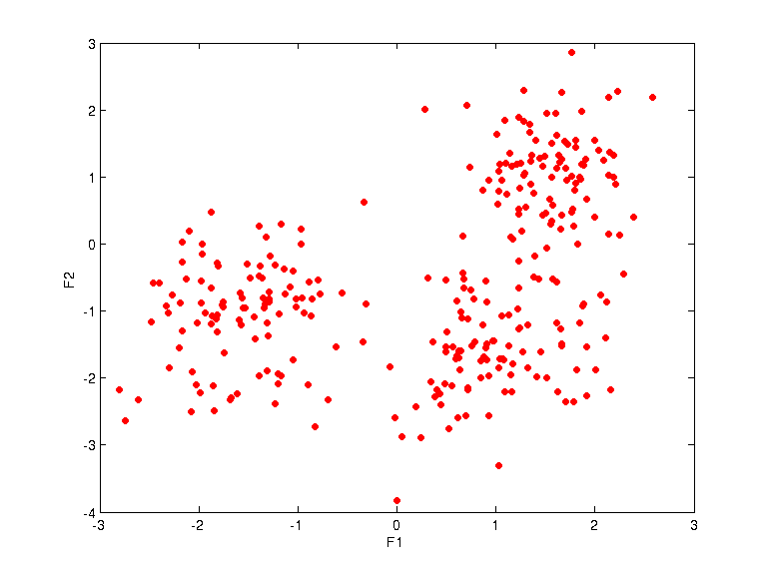
weights =
-0.1885 -0.9120 -0.1398 -0.3364
-0.7444 0.2196 -0.6253 0.0817
uqpc =
0.7907
0.7080
prototypes =
-2.1989 -3.8671 1.0000
-1.1507 -1.9515 2.0000
1.4321 1.5304 3.0000
K=4
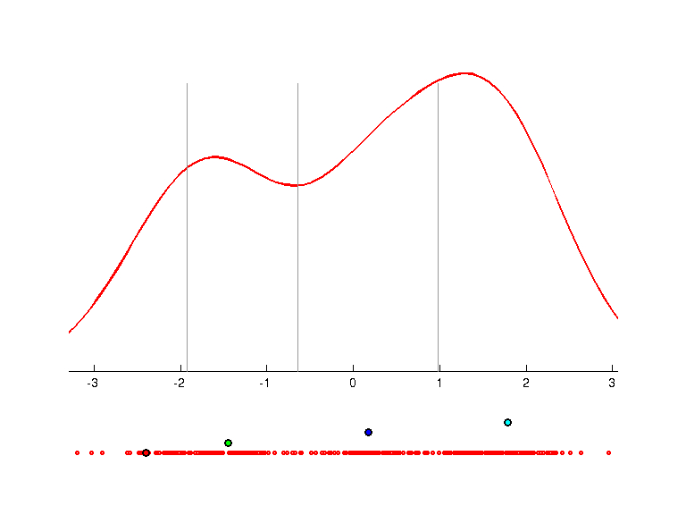 | 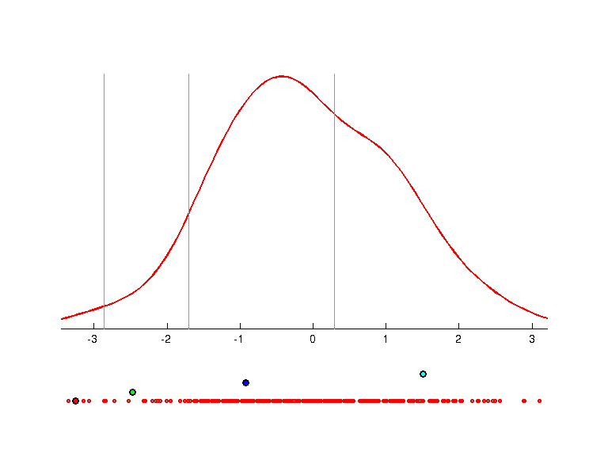 | 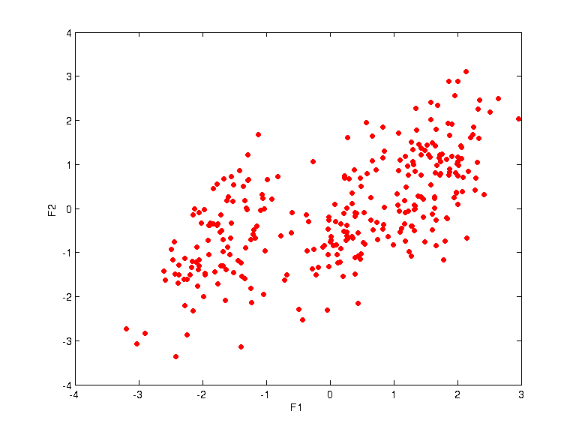
weights =
-0.4880 -0.8049 -0.2409 -0.2365
0.0233 0.3746 -0.6524 -0.6585
uqpc =
0.7820
0.7381
prototypes =
-2.4014 -3.2536 1.0000
-1.4535 -2.4752 2.0000
0.1759 -0.9203 3.0000
1.7892 1.5070 4.0000
K=5
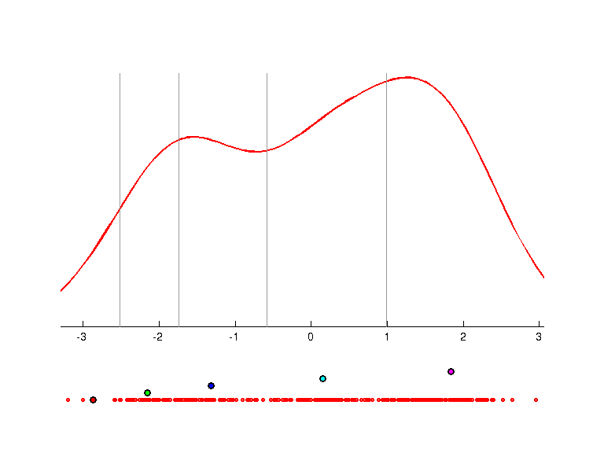 | 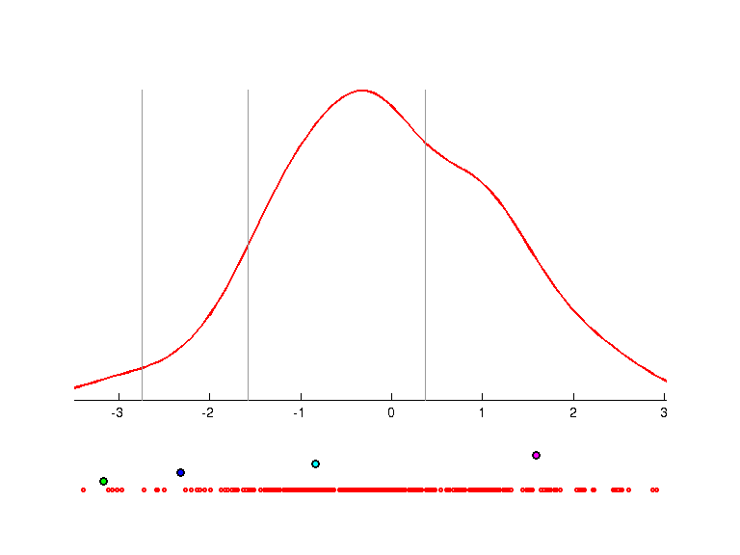 | 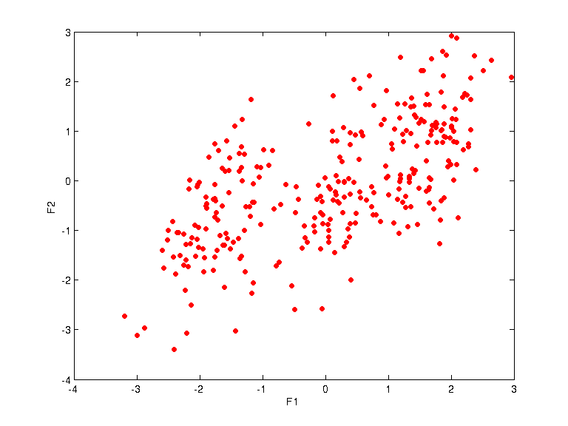
weights =
-0.5339 -0.7813 -0.2408 -0.2157
0.1538 0.2860 -0.7271 -0.6049
uqpc =
0.7693
0.5692
prototypes =
-2.8691 -3.8573 1.0000
-2.1556 -3.1742 2.0000
-1.3200 -2.3202 3.0000
0.1486 -0.8358 4.0000
1.8375 1.5860 5.0000
K=7
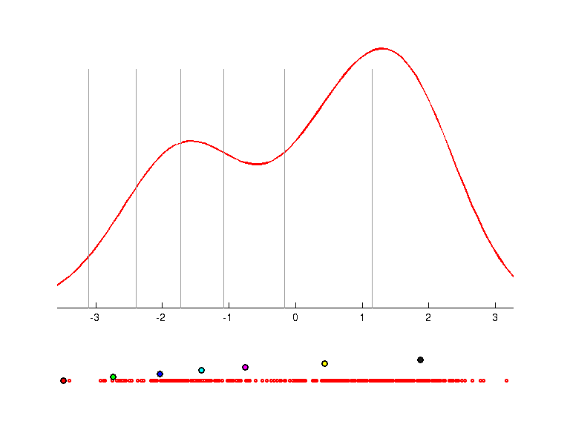 | 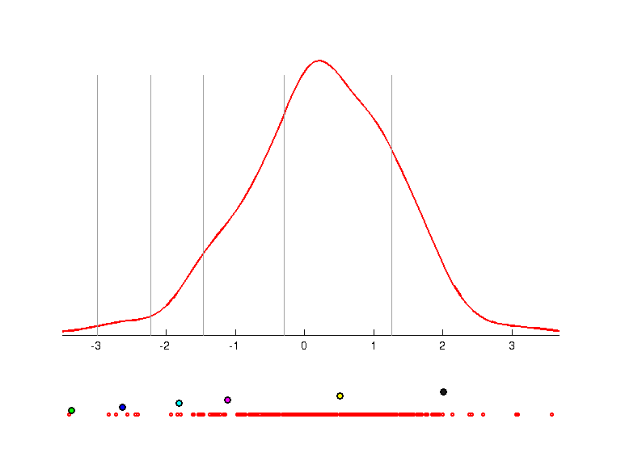 | 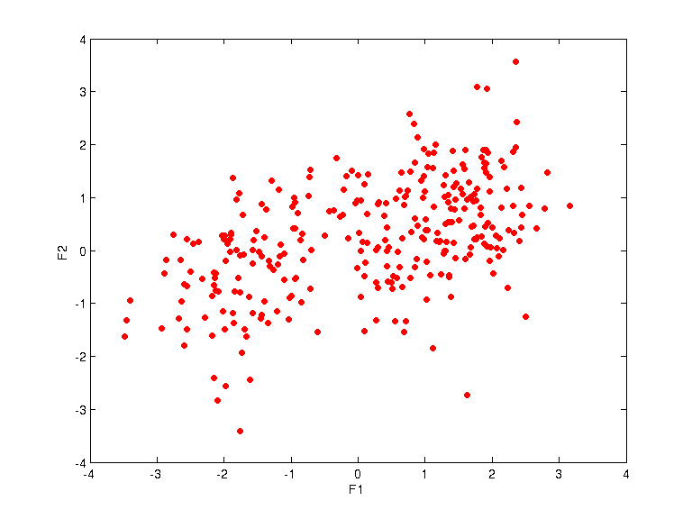
weights =
-0.2333 -0.8168 -0.4295 -0.3066
-0.2340 0.2986 0.2037 -0.9025
uqpc =
0.8034
0.6387
prototypes =
-3.4842 -3.7157 1.0000
-2.7395 -3.3734 2.0000
-2.0419 -2.6355 3.0000
-1.4110 -1.8129 4.0000
-0.7551 -1.1159 5.0000
0.4314 0.5135 6.0000
1.8740 2.0020 7.0000

Gauss2n2
Data description:
Brak
Scatter plot:
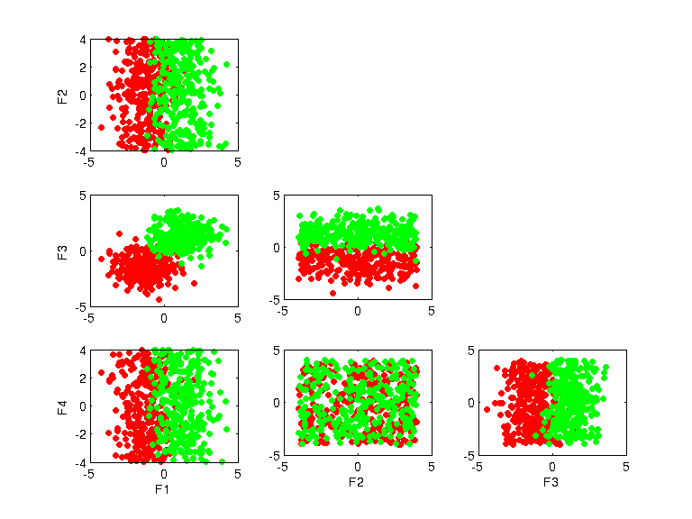
UQPC projections:
K=2
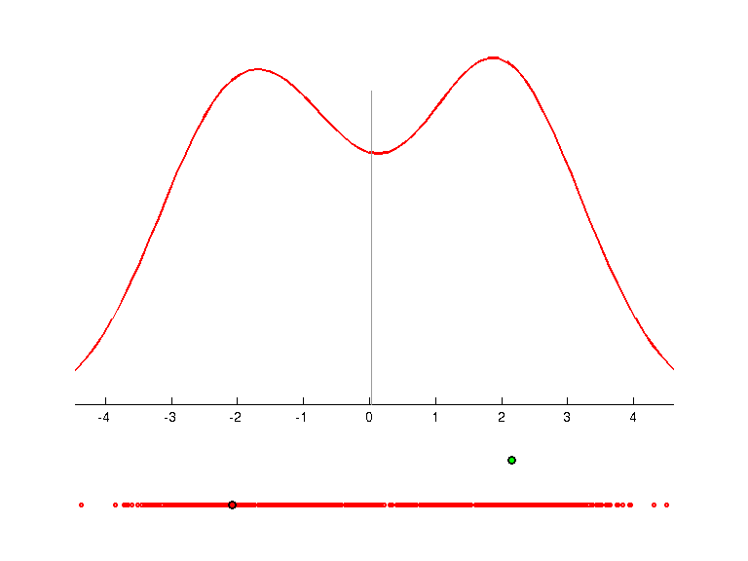 | 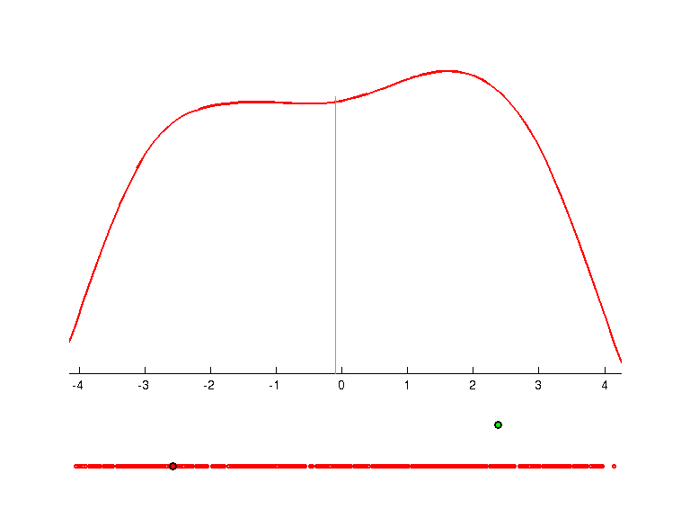 | 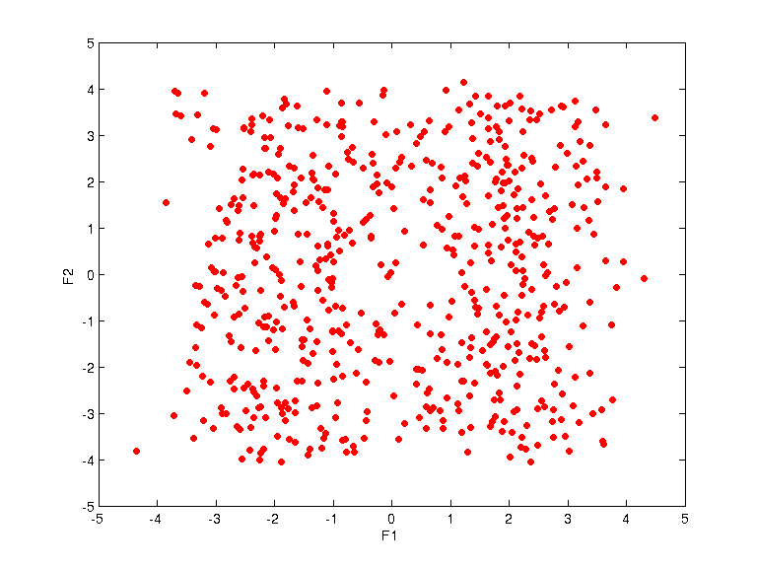
weights =
-0.5474 -0.0130 -0.8353 -0.0499
-0.0678 -0.0190 0.1039 -0.9921
uqpc =
0.7623
0.7148
prototypes =
-2.0850 -2.5750 1.0000
2.1489 2.3772 2.0000
K=5
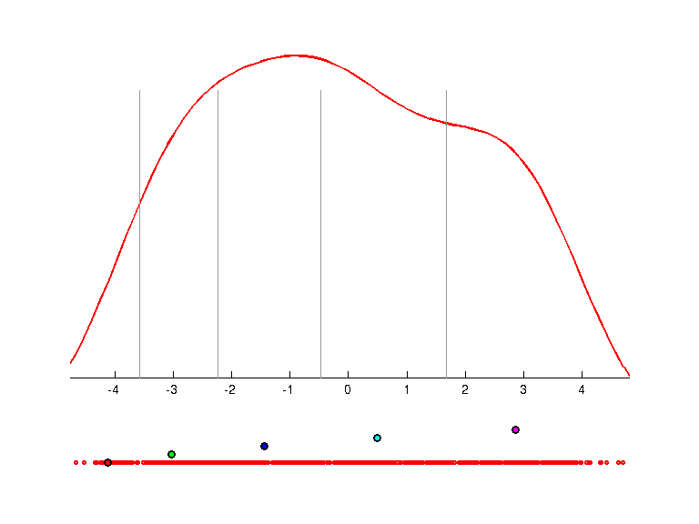 | 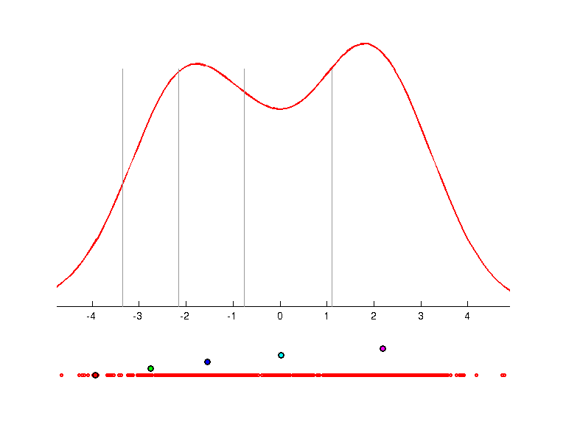 | 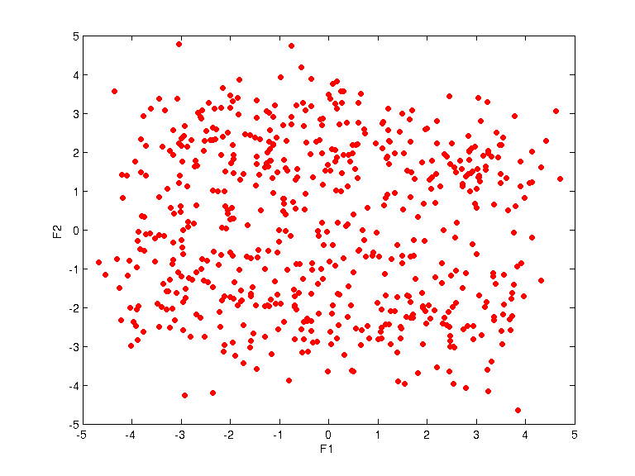
weights =
-0.1464 -0.9726 0.0322 -0.1776
-0.7847 0.1040 -0.6102 -0.0330
uqpc =
0.7600
0.7660
prototypes =
-4.1275 -3.9336 1.0000
-3.0375 -2.7567 2.0000
-1.4518 -1.5515 3.0000
0.4985 0.0269 4.0000
2.8644 2.1928 5.0000

Wine
Data description:
Brak
UQPC projections:
K=2
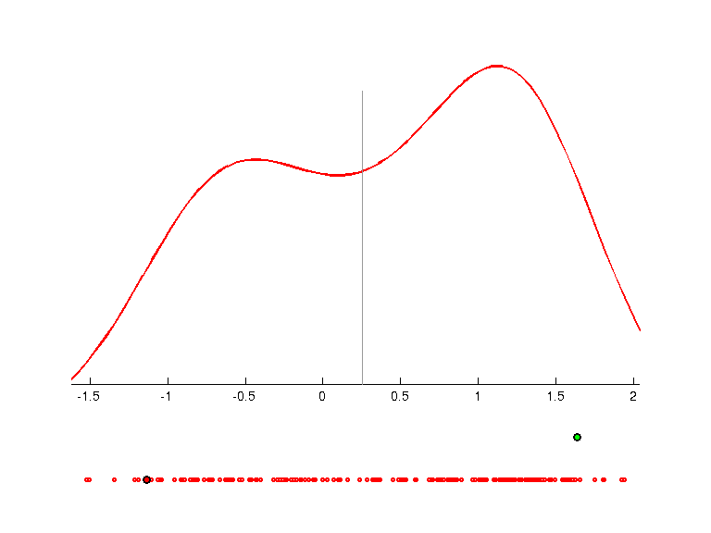 | 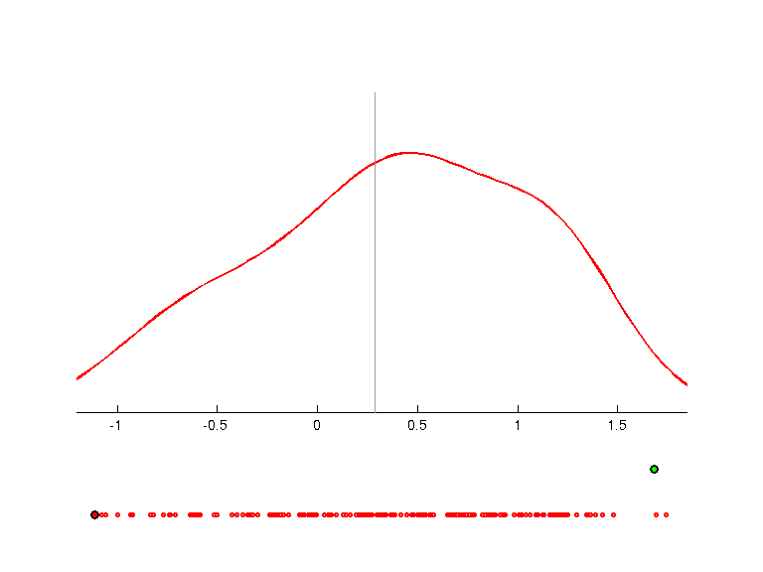 | 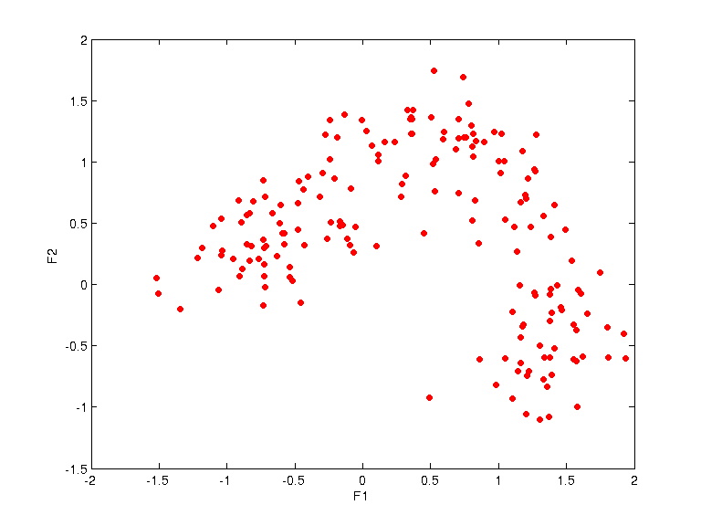
weights =
Columns 1 through 8
-0.3237 0.0631 -0.1040 0.1697 -0.1642 -0.3865 -0.4025 0.2520
-0.4015 -0.4233 -0.1920 -0.1199 -0.1831 0.0080 0.1537 -0.1619
Columns 9 through 13
-0.2569 -0.0573 -0.2132 -0.3961 -0.4221
0.0569 -0.4799 0.2027 0.3611 -0.3463
uqpc =
0.6229
0.4278
prototypes =
-1.1345 -1.1107 1.0000
1.6382 1.6810 2.0000
K=5
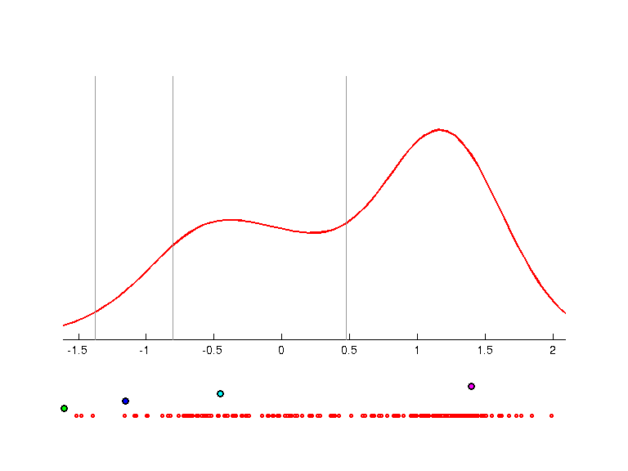 | 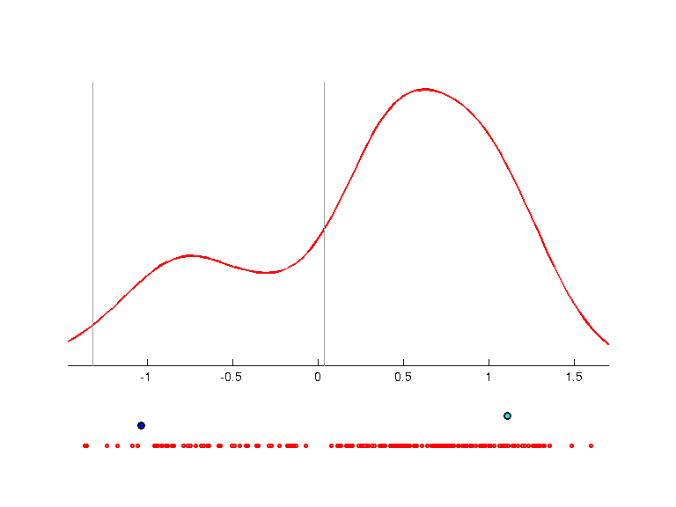 | 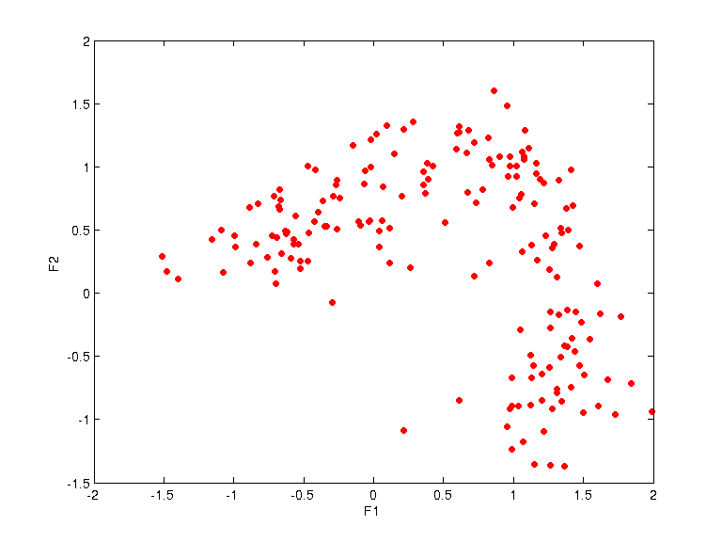
weights =
Columns 1 through 8
-0.2767 0.0715 -0.0725 0.1774 -0.2123 -0.4594 -0.3916 0.1295
-0.3216 -0.4882 -0.0947 -0.0845 -0.0773 -0.0161 0.2164 -0.2873
Columns 9 through 13
-0.2858 -0.1855 -0.1341 -0.2287 -0.5186
0.0427 -0.4911 0.2989 0.3718 -0.1898
uqpc =
0.5949
0.4078
prototypes =
-2.5708 -3.0434 1.0000
-1.6053 -1.6025 2.0000
-1.1533 -1.0364 3.0000
-0.4520 1.1089 4.0000
1.3992 3.5815 5.0000

