QPC_simple (17.04.2010 - beledne wyniki)

OPIS
Uczenie 2 kierunkow QPC startujac z prototypami w centrach klas.
Kierunek inicjowany jest losowo.
Polozenie prototypow optymalizowane wraz z wagami, rownoczesnie ze wsp. uczenia odpowiednio:
lr=0.1 plr=0.1
Test przeprowadzony dla szeregu danych.
Polecenie:
qpctrain_simple(x,y,'learningRate',0.1,'plr',0.1);
Konfiguracja:
procedure = qpcprot
dataname = abalone
vectors = 4177
features = 7
OptMethod = gd
learningRate = 0.100000
prototypes = 28
proto lr = 0.100000
eps = 0.001000
start init. = 1
end init = 3
multistart = yes
maxIterations = 1000
qpc function = @(wx,p)qpcfunction_dt(x,ci,wx,p,func)
function = @(xx)f_gauss(xx,beta)
beta = 0.100000

Projekcje

appendi
Direction 1
QPC=0.4983
LVQ acc.=0.8019
LVQ 1D acc.=0.8019
--
Direction 2
QPC=0.5381
LVQ acc.=0.8208
LVQ 1D acc.=0.8396
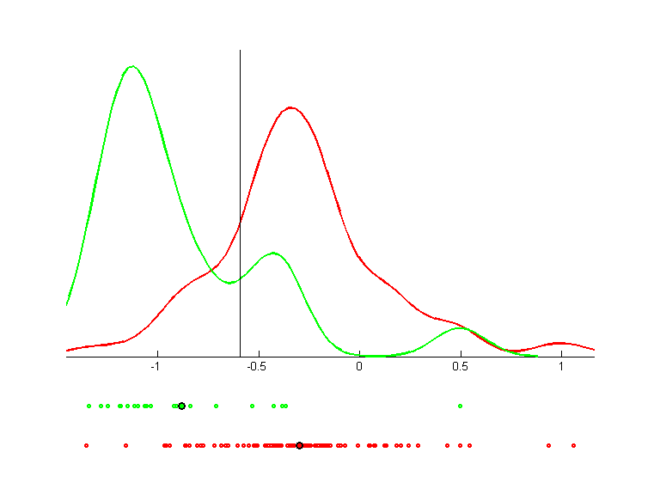 | 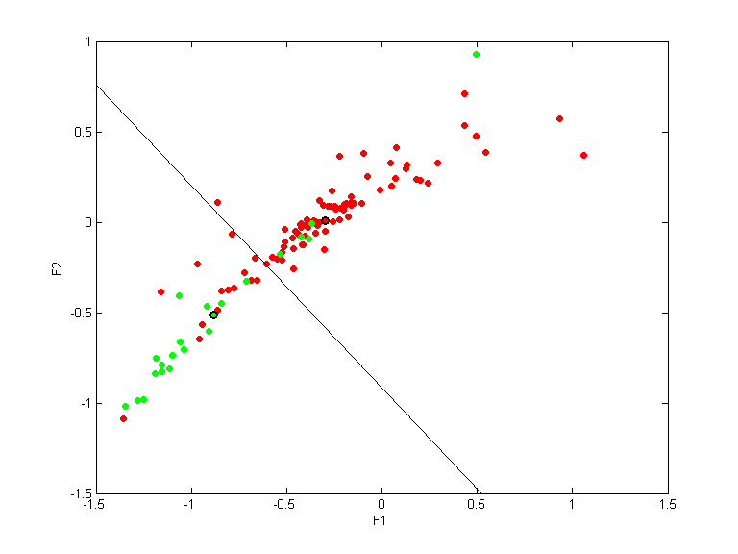 | 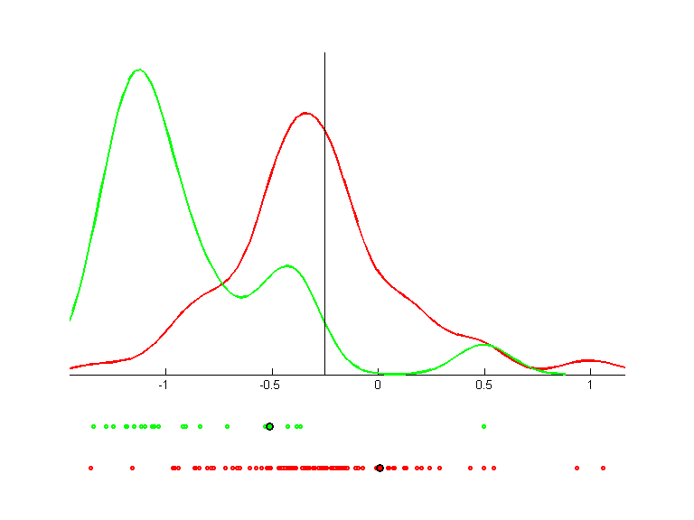

arcene_train
Direction 1
QPC=0.0000
LVQ acc.=0.6200
LVQ 1D acc.=0.6200
--
Direction 2
QPC=0.0000
LVQ acc.=0.6100
LVQ 1D acc.=0.6200
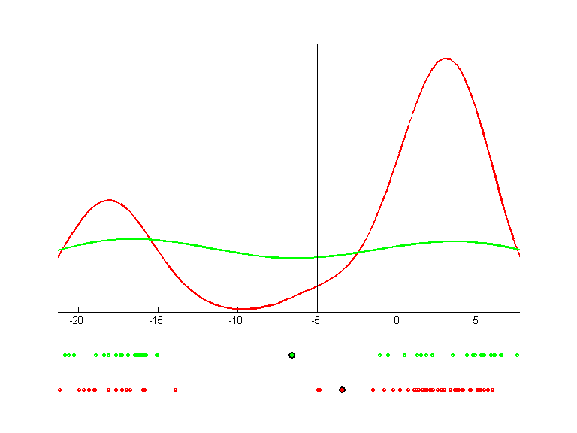 | 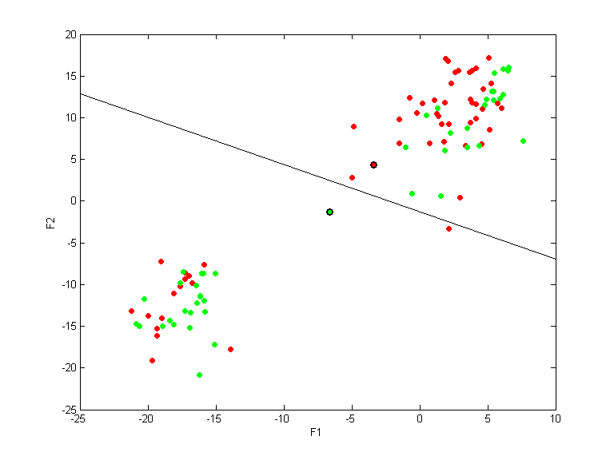 | 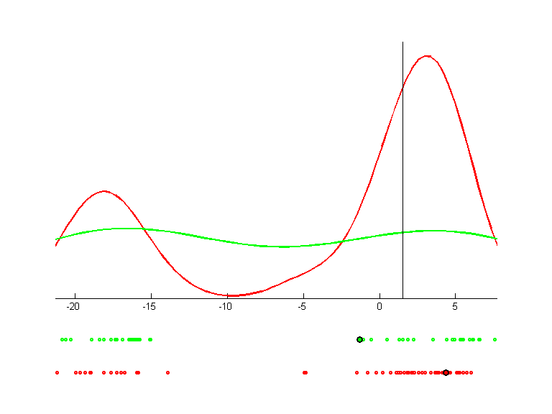

breast-nomis
Direction 1
QPC=0.7179
LVQ acc.=0.9502
LVQ 1D acc.=0.9502
--
Direction 2
QPC=0.8124
LVQ acc.=0.9634
LVQ 1D acc.=0.9634
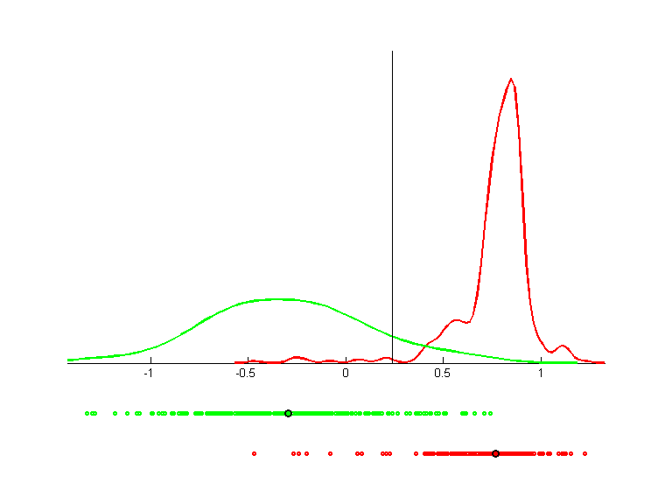 | 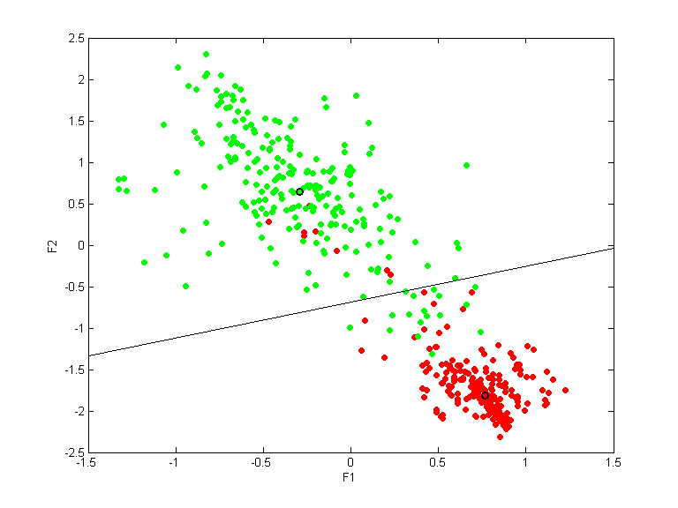 | 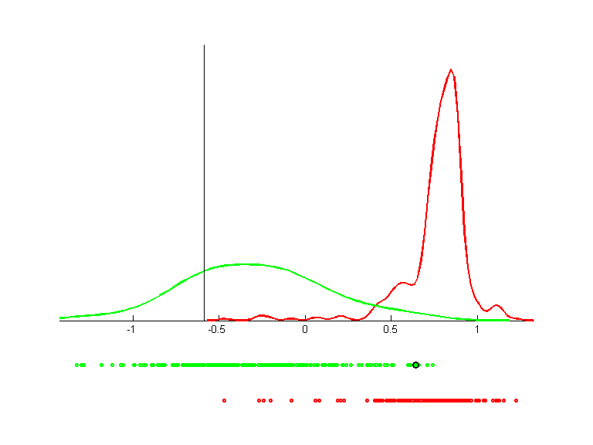

circ4n2
Direction 1
QPC=0.2638
LVQ acc.=0.2825
LVQ 1D acc.=0.2825
--
Direction 2
QPC=0.2431
LVQ acc.=0.2863
LVQ 1D acc.=0.2850
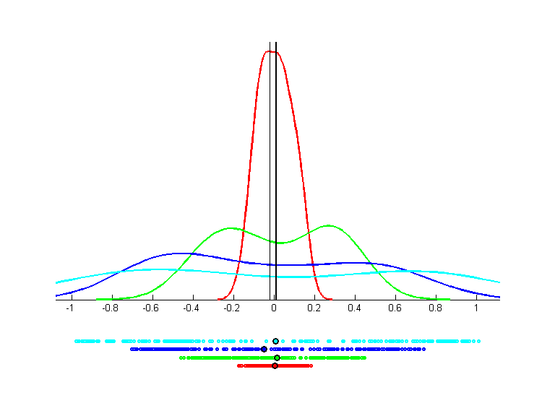 | 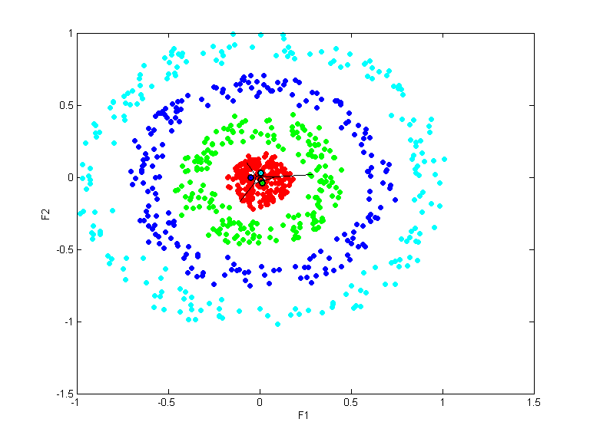 | 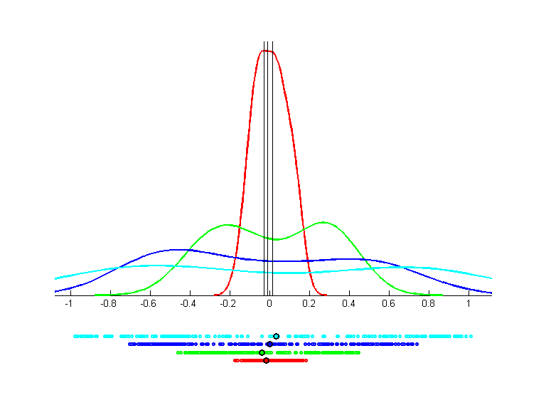

glass
Direction 1
QPC=0.4801
LVQ acc.=0.4860
LVQ 1D acc.=0.4860
--
Direction 2
QPC=0.3823
LVQ acc.=0.4766
LVQ 1D acc.=0.4299
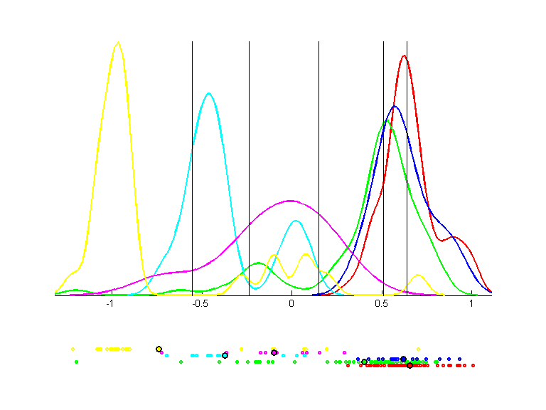 | 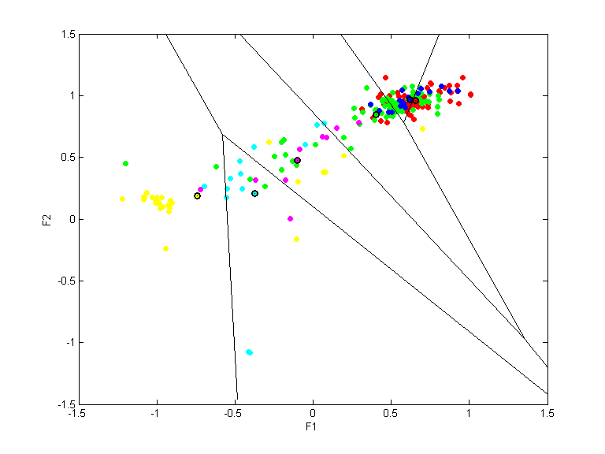 | 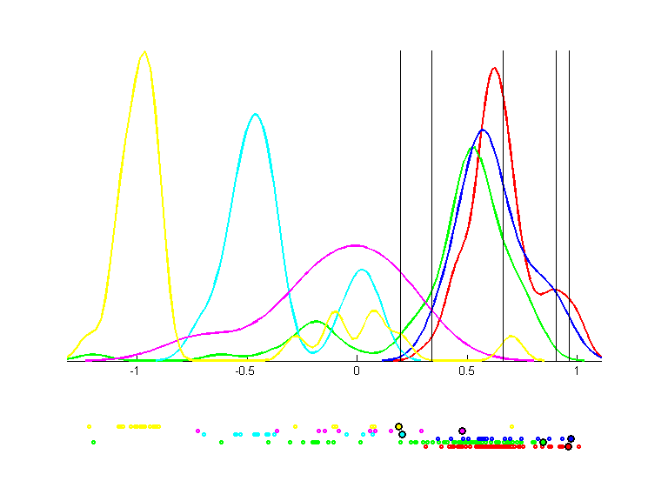

heart-nomis
Direction 1
QPC=0.5307
LVQ acc.=0.7643
LVQ 1D acc.=0.7643
--
Direction 2
QPC=0.4935
LVQ acc.=0.7980
LVQ 1D acc.=0.8114
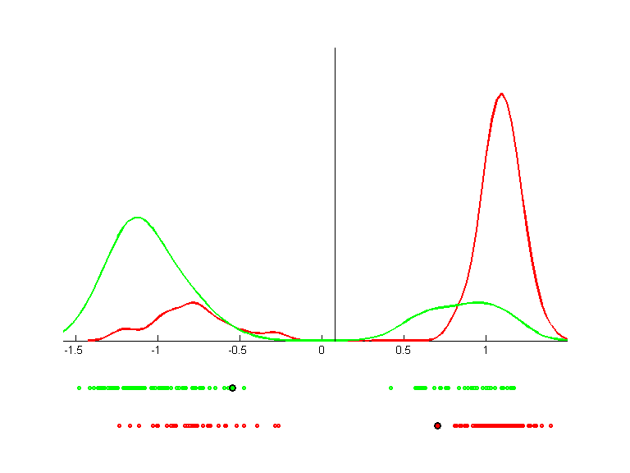 | 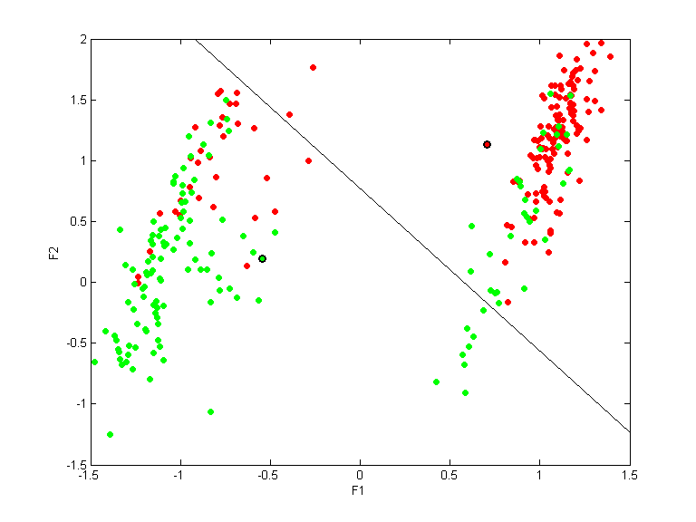 | 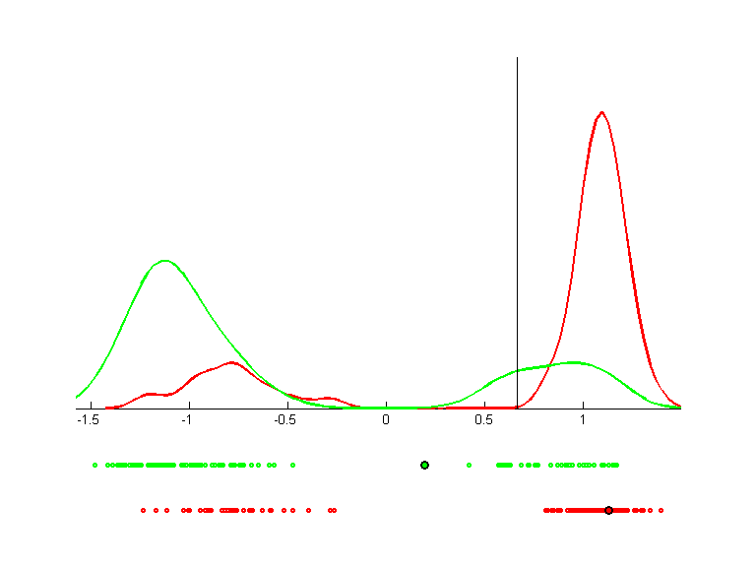

ionosphere
Direction 1
QPC=0.6669
LVQ acc.=0.8650
LVQ 1D acc.=0.8650
--
Direction 2
QPC=0.5384
LVQ acc.=0.7750
LVQ 1D acc.=0.7800
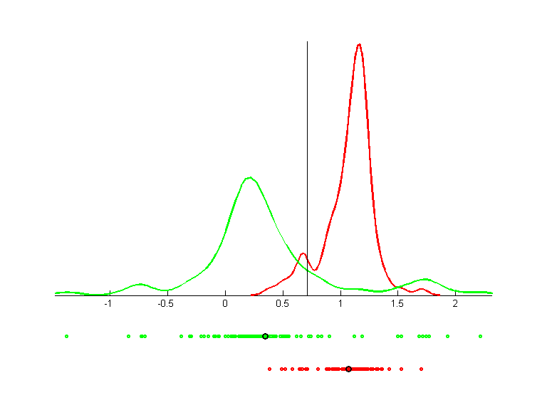 | 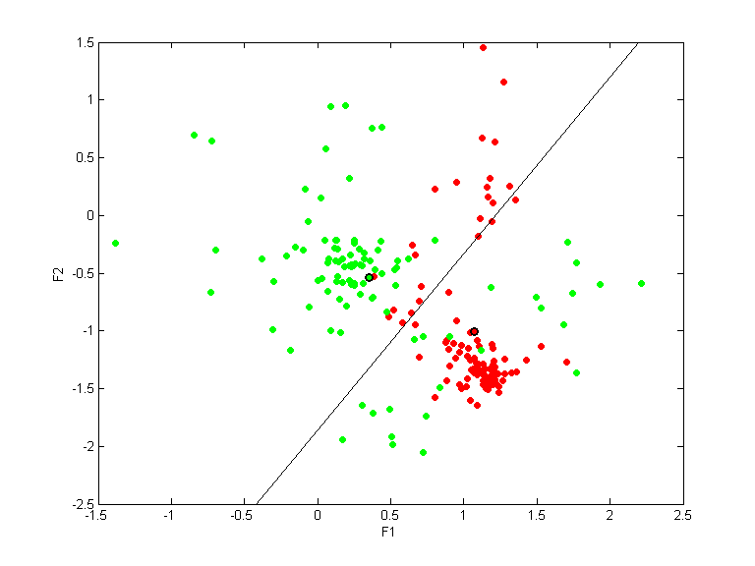 | 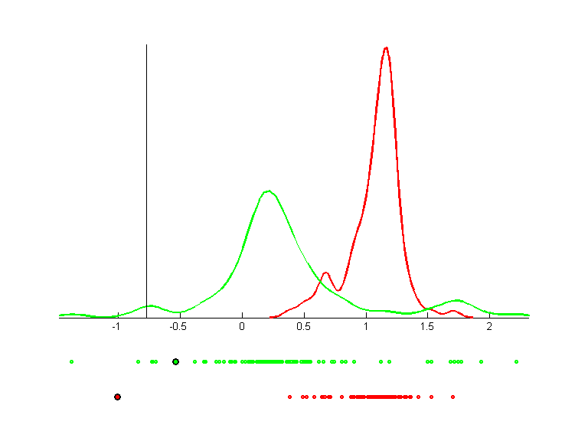

iris
Direction 1
QPC=0.8478
LVQ acc.=0.9867
LVQ 1D acc.=0.9867
--
Direction 2
QPC=0.6655
LVQ acc.=0.9533
LVQ 1D acc.=0.8400
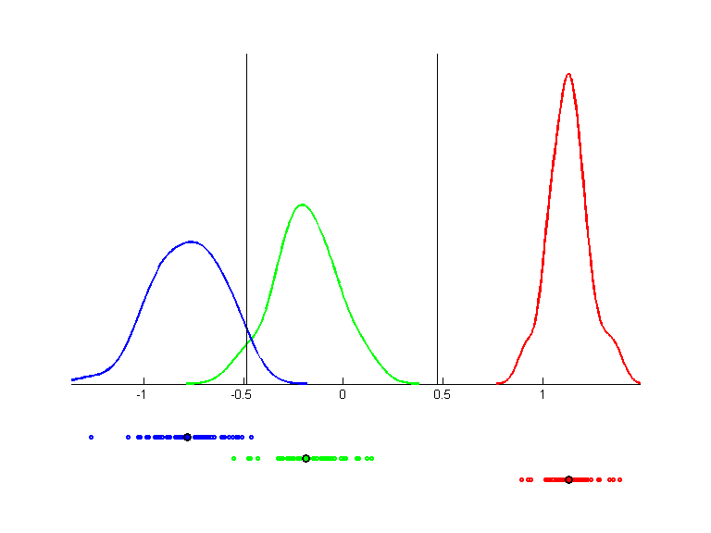 | 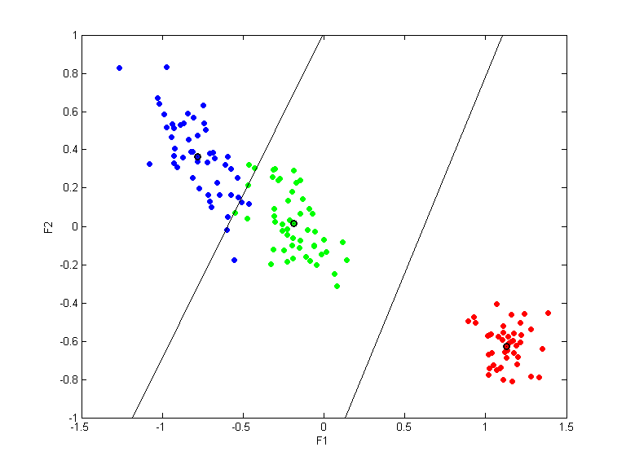 | 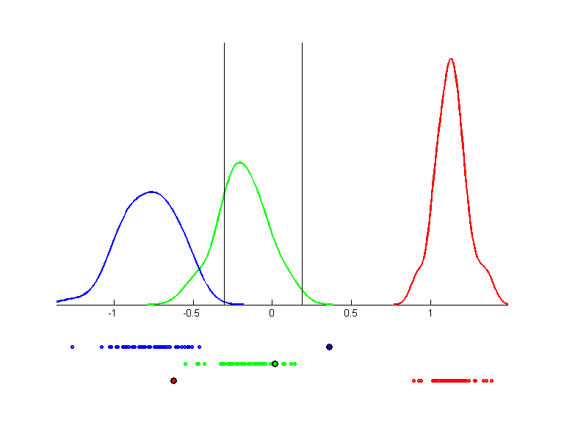

lbreast-nomis
Direction 1
QPC=0.2927
LVQ acc.=0.6606
LVQ 1D acc.=0.6606
--
Direction 2
QPC=0.3061
LVQ acc.=0.7004
LVQ 1D acc.=0.6859
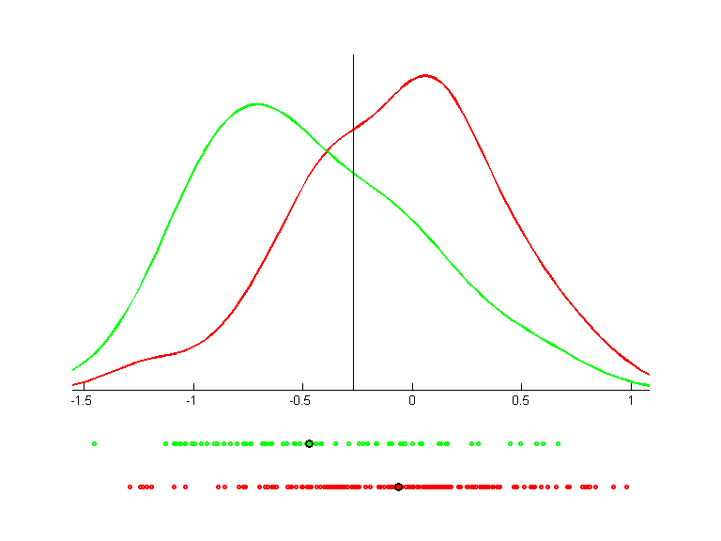 | 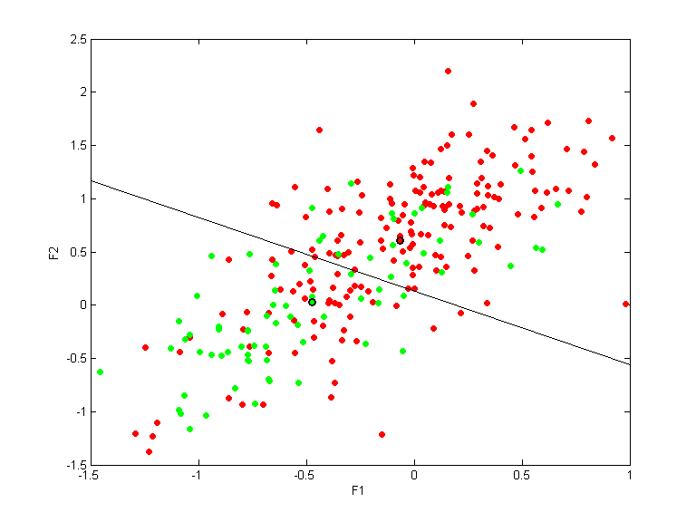 | 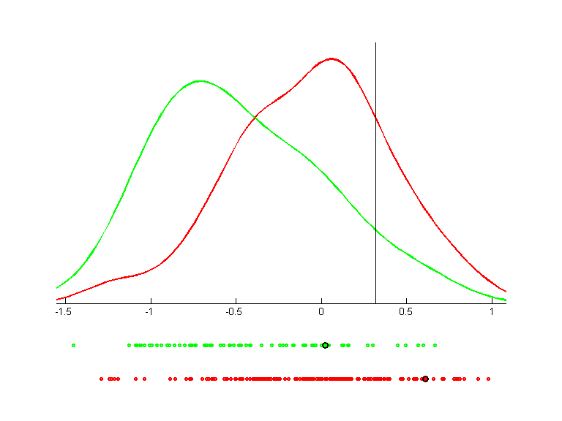

madelon_train
Direction 1
QPC=0.4152
LVQ acc.=0.7720
LVQ 1D acc.=0.7720
--
Direction 2
QPC=0.3509
LVQ acc.=0.7135
LVQ 1D acc.=0.7185
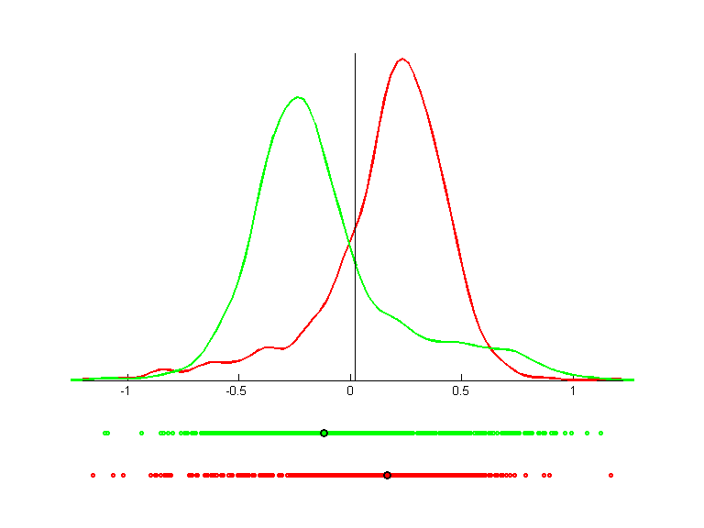 | 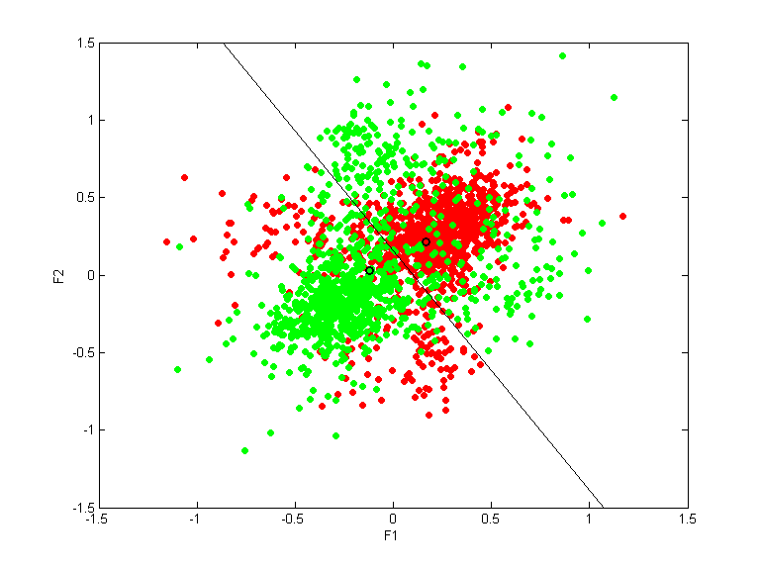 | 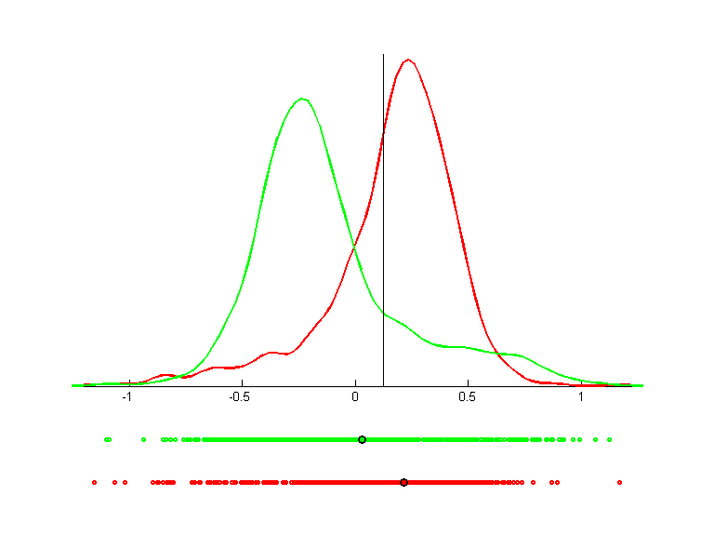

monks1
Direction 1
QPC=0.3355
LVQ acc.=0.6613
LVQ 1D acc.=0.6613
--
Direction 2
QPC=0.4364
LVQ acc.=0.6613
LVQ 1D acc.=0.7177
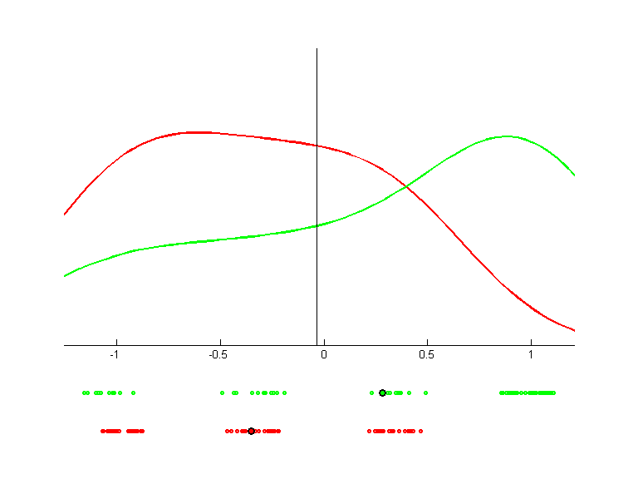 | 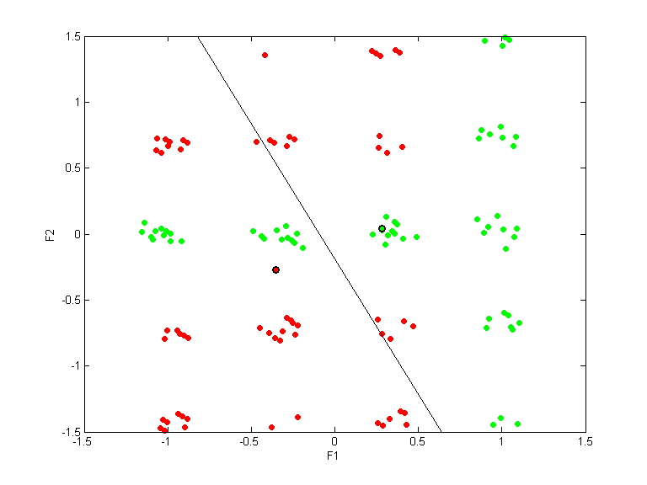 | 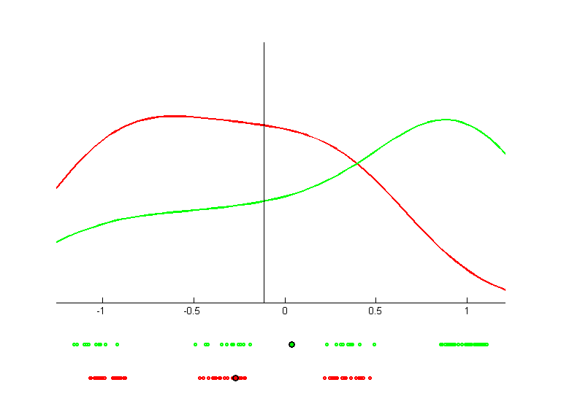

monks2
Direction 1
QPC=0.1342
LVQ acc.=0.5503
LVQ 1D acc.=0.5503
--
Direction 2
QPC=0.1353
LVQ acc.=0.5562
LVQ 1D acc.=0.5385
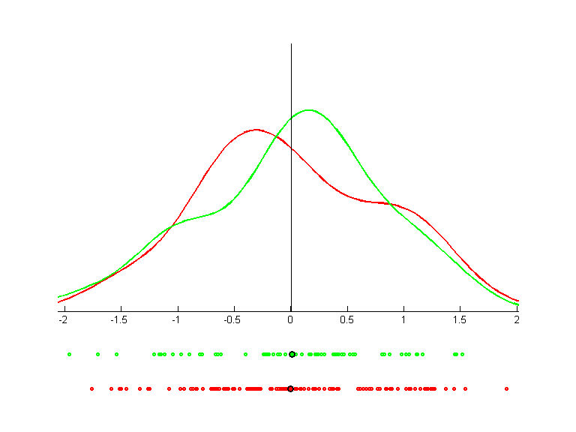 | 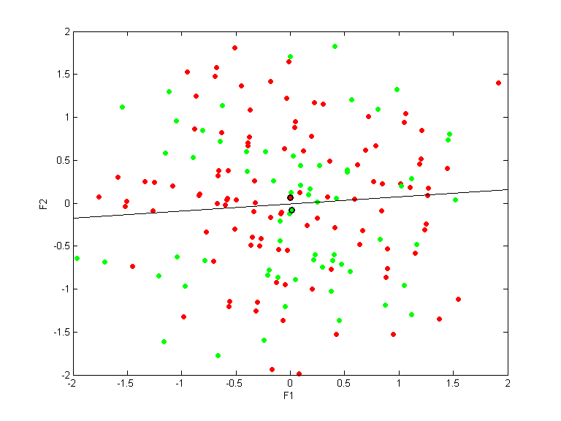 | 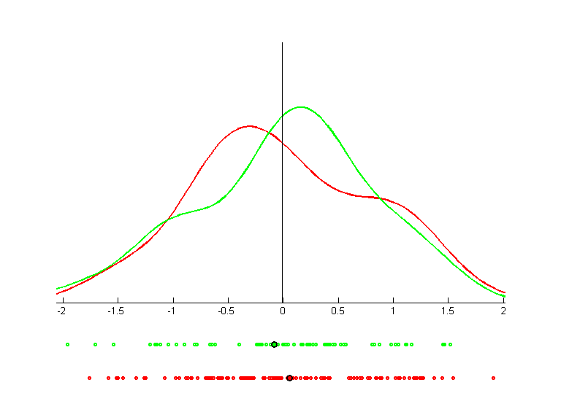

monks3
Direction 1
QPC=0.4230
LVQ acc.=0.8033
LVQ 1D acc.=0.8033
--
Direction 2
QPC=0.0994
LVQ acc.=0.8115
LVQ 1D acc.=0.4672
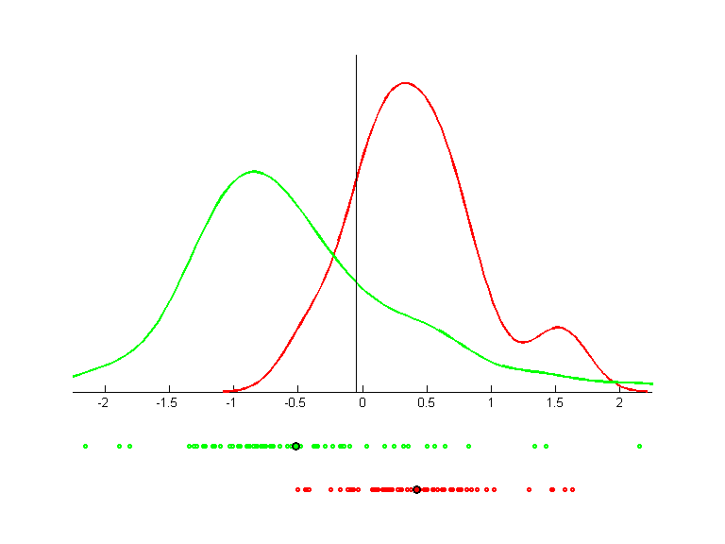 | 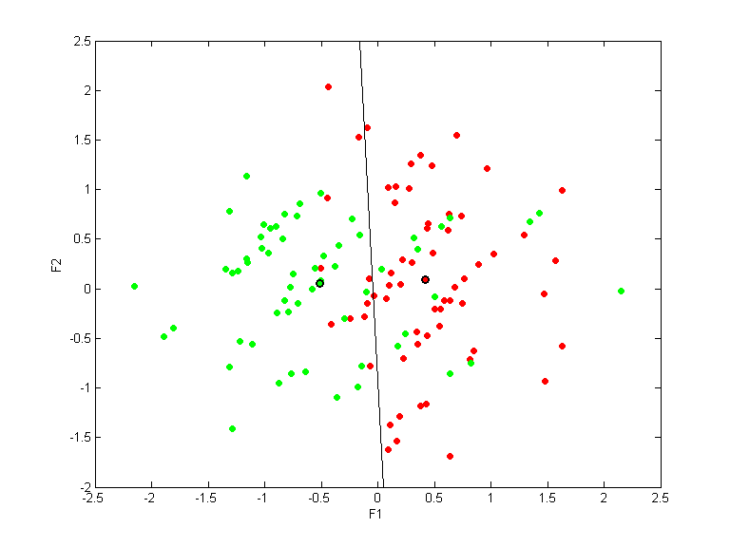 | 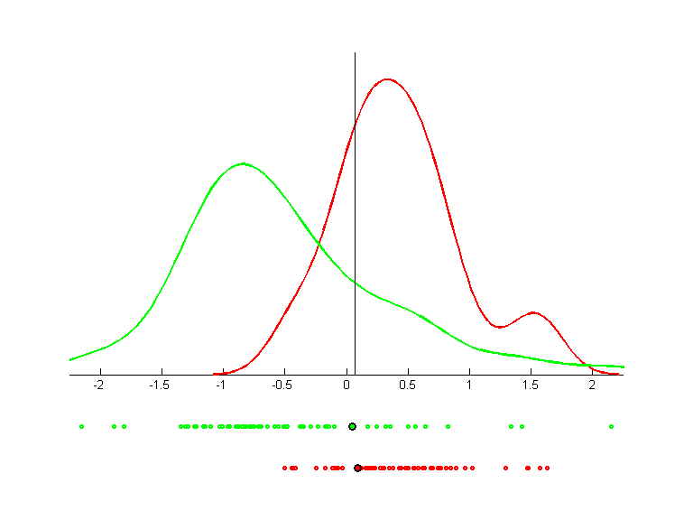

parity-10
Direction 1
QPC=0.0000
LVQ acc.=0.5000
LVQ 1D acc.=0.5000
--
Direction 2
QPC=0.0000
LVQ acc.=0.5127
LVQ 1D acc.=0.5215
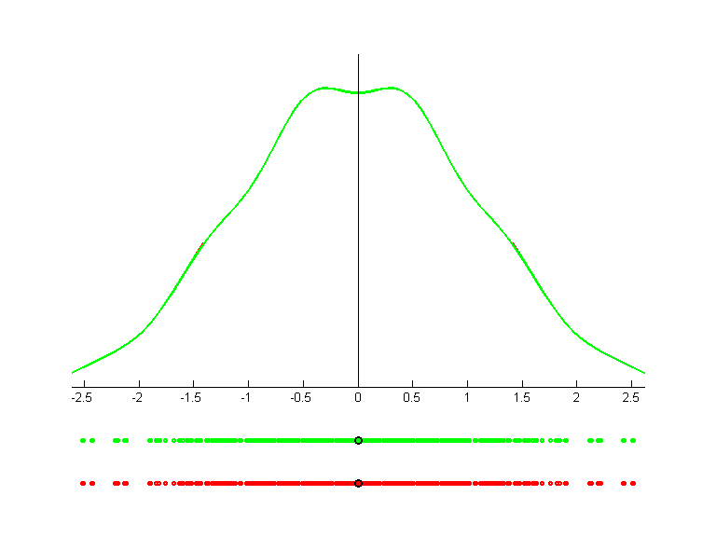 | 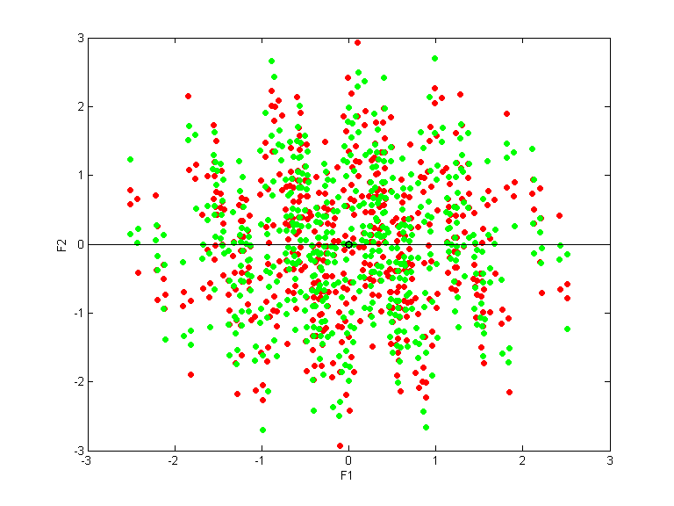

parity-9
Direction 1
QPC=0.0180
LVQ acc.=0.5000
LVQ 1D acc.=0.5000
--
Direction 2
QPC=0.2804
LVQ acc.=0.4043
LVQ 1D acc.=0.3320
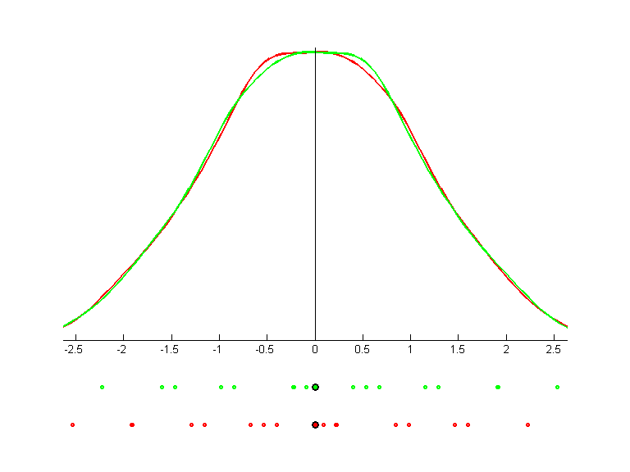 | 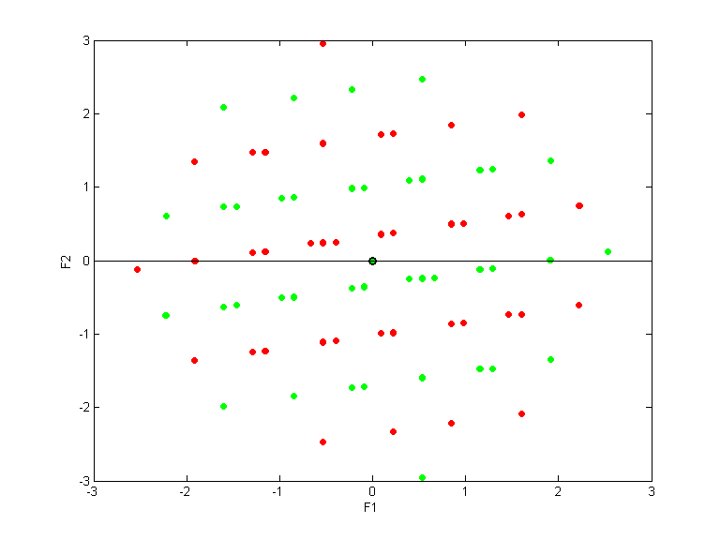

thyr-train
Direction 1
QPC=0.4350
LVQ acc.=0.6853
LVQ 1D acc.=0.6853
--
Direction 2
QPC=0.1848
LVQ acc.=0.6031
LVQ 1D acc.=0.4881
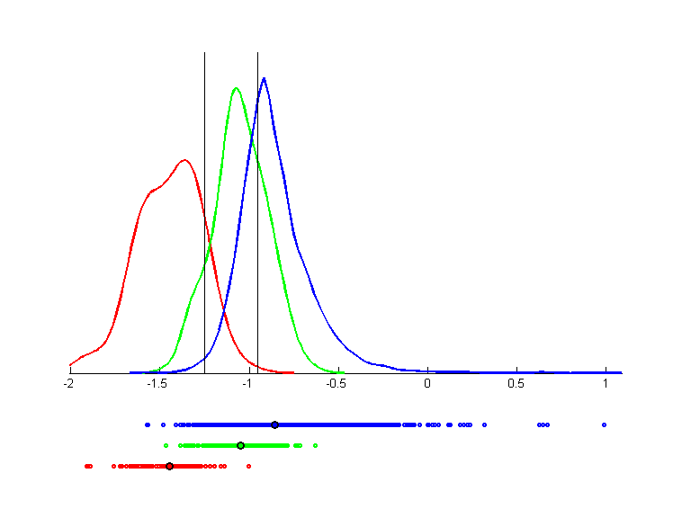 | 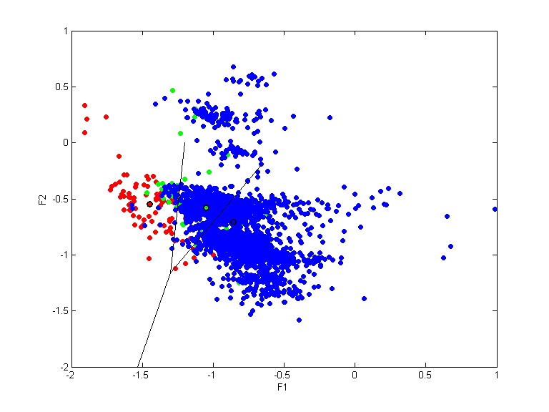 | 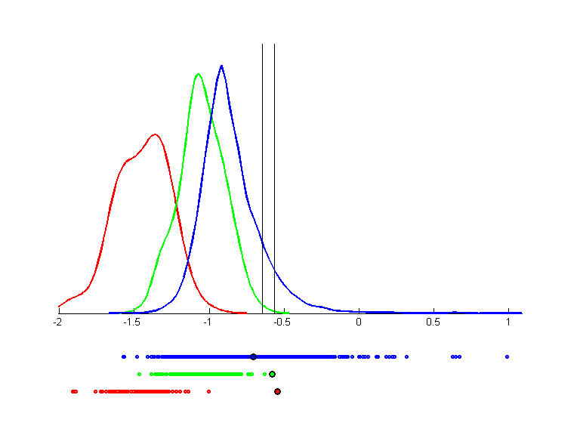

wine
Direction 1
QPC=0.7807
LVQ acc.=0.9494
LVQ 1D acc.=0.9494
--
Direction 2
QPC=0.6784
LVQ acc.=0.9831
LVQ 1D acc.=0.8708
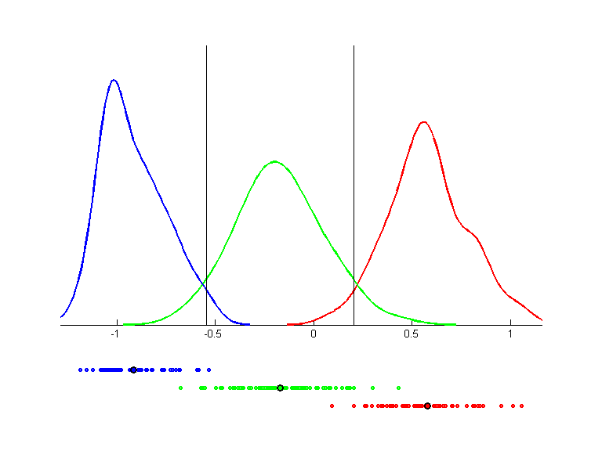 | 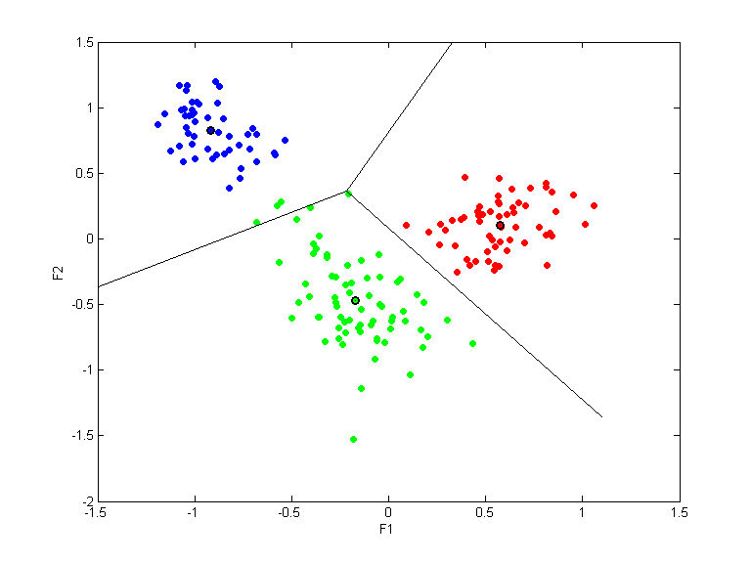 | 

