QPC + LVQ - Wizualizacje

Ustawienia modelu
Method lvq+qpc
Initialization 5
LVQ learnign rate 0.010000
Attraction force 0.050000
Max. projections 5
K range 2 10 20
Attraction step 100
Precision (eps) 0.030000

Wyniki uczenia
Dataset |  |  | Model
 | vec | feat | acc. | #P | #K
appendi | 106 | 7 | 88.68 | 1.00 | 2.00
australian-statlog | 690 | 14 | 86.09 | 1.00 | 2.00
bitsymetry15x100 | 100 | 15 | 98.00 | 1.00 | 3.00
bitsymetry20x100 | 100 | 20 | 100.00 | 1.00 | 3.00
breast-cancer-wisconsin-nomis | 683 | 9 | 96.19 | 1.00 | 2.00
breast-nomis | 683 | 9 | 96.19 | 1.00 | 2.00
czerniak-trs | 250 | 14 | 89.60 | 1.00 | 4.00
glass | 214 | 9 | 61.68 | 1.00 | 4.00
heart-statlog | 270 | 13 | 83.70 | 1.00 | 2.00
ionosphere | 200 | 34 | 89.50 | 1.00 | 2.00
iris | 150 | 4 | 98.00 | 1.00 | 3.00
lbreast-nomis | 277 | 9 | 76.17 | 1.00 | 2.00
led500 | 500 | 7 | 59.20 | 1.00 | 9.00
monks1 | 124 | 6 | 94.35 | 2.00 | 4.00
monks2 | 169 | 6 | 84.02 | 1.00 | 3.00
monks3 | 122 | 6 | 87.70 | 1.00 | 2.00
parity-10 | 1024 | 10 | 98.05 | 1.00 | 7.00
wine | 178 | 13 | 95.51 | 1.00 | 3.00

Appendicitis
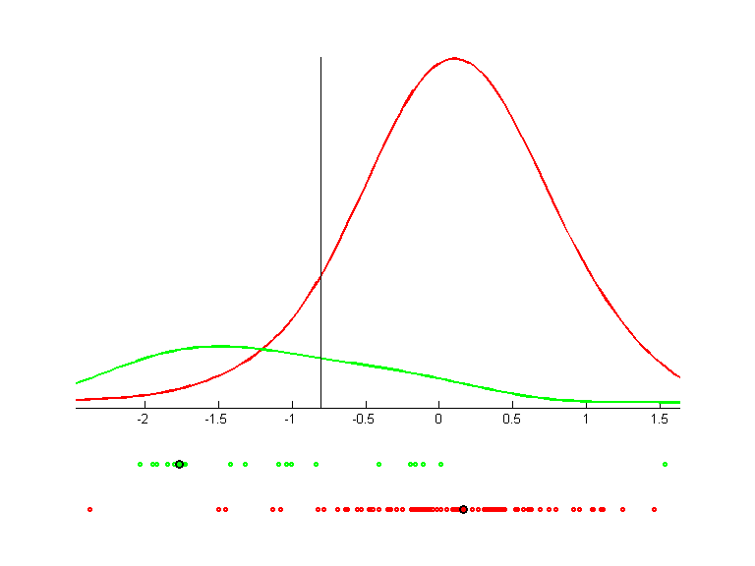

Australian (statlog)
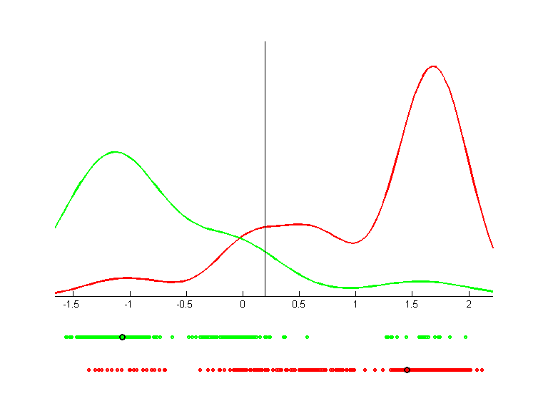

Bit Symatry 20x100
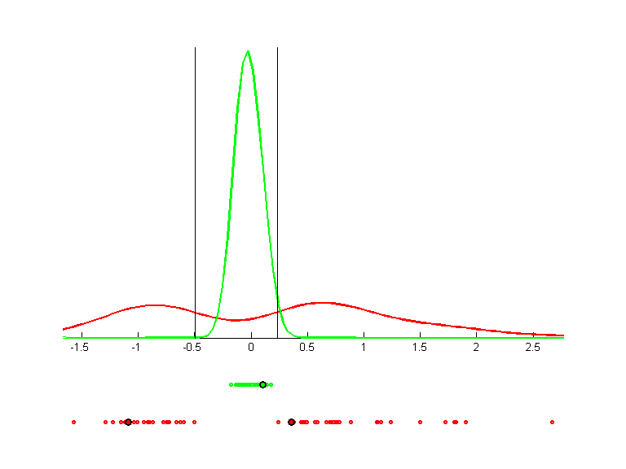

Breast Cancer W. (nomis)
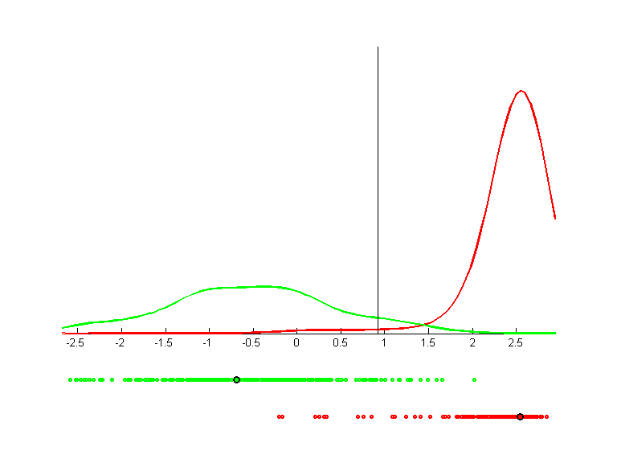

Iris
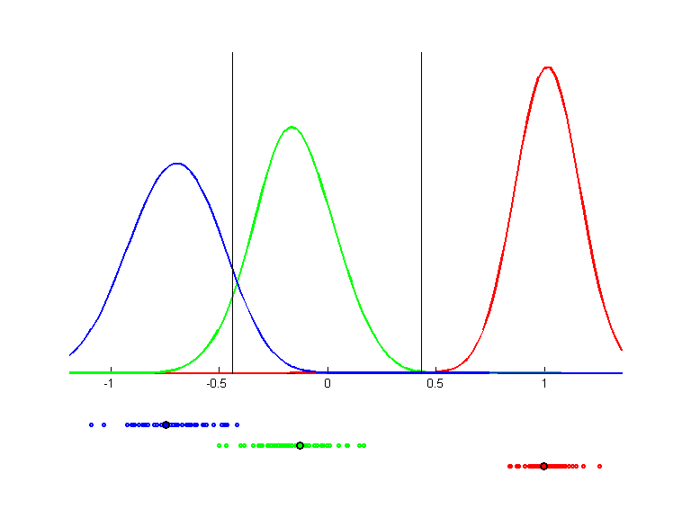

Ionosphere
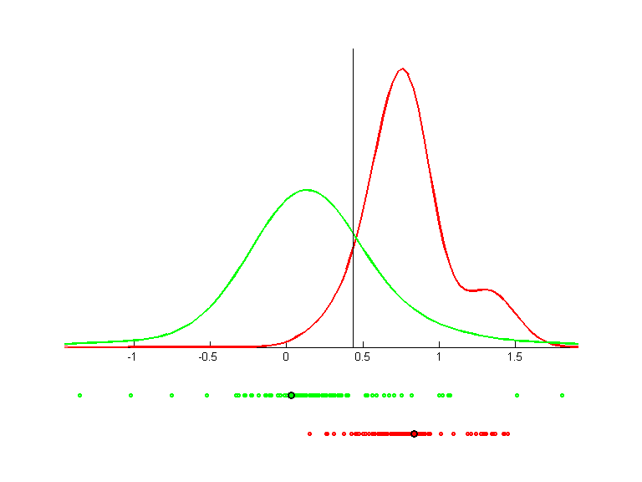

L. Breast
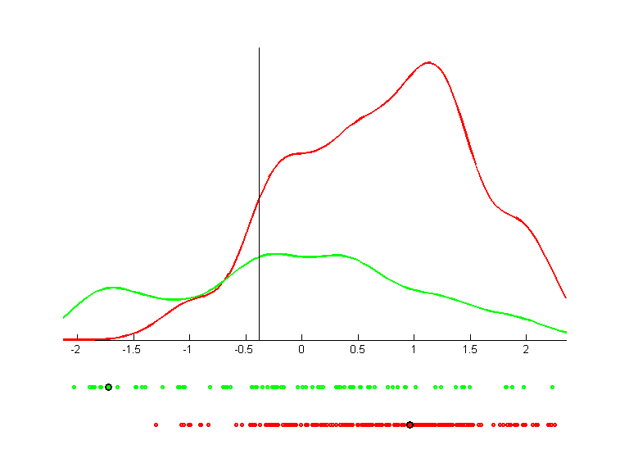

Monk's 1
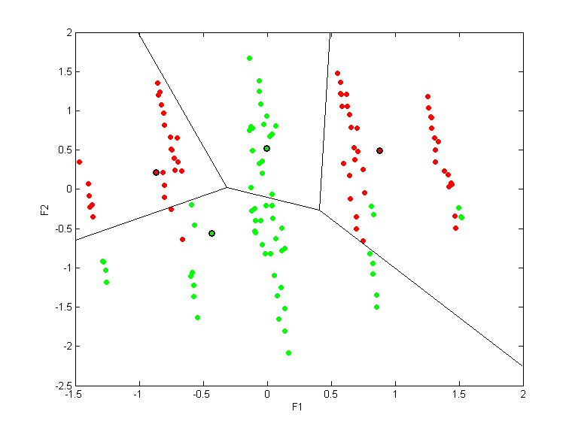

Monk's 2
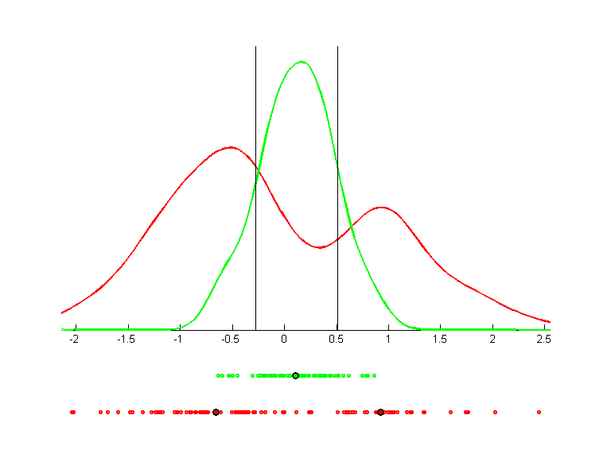

Parity 10
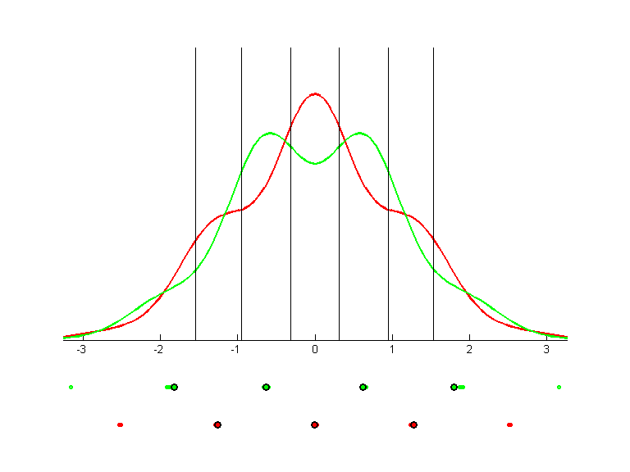

Wine


